

**AAPP006-4-2-SDP**

**GROUP ASSIGNMENT**

**SOFTWARE DEVELOPMENT PROJECT**

**EDUCATIONAL GOAT (EDG)**

**UCDF2207 ICT (SE)**

**HAND OUT DATE : 5TH MARCH 2024**

**HAND IN DATE : 13TH MAY 2024**

**WEIGHTAGE : 40 %**

**LECTURER : JUSTIN GILBERT ALEXIUS SILVESTER**

**SUBJECT : SOFTWARE DEVELOPMENT PROJECT**

**GROUP MEMBER : ANNIE KIU CHI WEN (TP070557)**

**DING DER XIN (TP069485)**

**CHUA KIAN HO (TP070332)**

**CHENG XI HONG (TP068784)**

Table of Contents

Acknowledgement 5

1.0 Abstract 6

2.0 Workload Matrix 7

3.0 Introduction 7

3.1 Project Background 7

3.2 Problem Context 8

3.3 Proposed Solution 8

3.4 Project Objectives 9

3.5 Project Scope 9

3.5.1 User Research: 9

3.5.2 Design & Development: 9

3.5.3 Content Adaptation: 9

3.5.4 User Feedback: 10

3.6 Chosen Methodology 10

4.0 Project Plan 10

4.1 System Development Methodology - Spiral Methodology 10

4.1.1 Planning 10

4.1.2 Risk Analysis 11

4.1.3 Engineering 11

4.1.4 Evaluation 12

4.2 Project Gantt Chart 13

5.0 System Hierarchy Chart 14

6.0 Context Diagram 15

7.0 Data Flow Diagrams Level 0 16

7.1 Data Flow Diagram Level 1 17

7.1.1 Annie Kiu Chi Wen (TP070557) 17

7.1.2 Chua Kian Ho (TP070332) 20

7.1.3 Ding Der Xin (TP069485) 24

7.1.4 Cheng Xi Hong (TP068784) 26

7.2 Data Dictionary 29

7.2.1 Process 29

7.2.2 Data Flow 30

7.2.3 Data Store 33

8.0 Entity Relationship Diagram 34

9.0 Pseudocode 35

9.1 Annie Kiu Chi Wen (TP070557) 35

9.2 Chua Kian Ho (TP 48

9.3 Ding Der Xin 60

9.4 Cheng Xi Hong 71

10.0 Screens Design and User Manual 82

10.1 Customer 82

10.1.1 Main Dashboard (Before Log In) User part. 82

9.1.2 Log In (Creating Profile). 89

9.1.3 Log in User Dashboard 94

10.2 Admin 104

11.0 Test Plan 109

11.1 Unit Testing 110

11.2 User Acceptance Testing 111

12.0 Significant Source Codes 115

12.1 Choose Colour Mode Function 118

12.2 Choose Text Size Function 120

12.3 Forgot Password Function 125

12.4 Reset Password Function 126

12.0 Conclusion 128

12.1 Assumptions 128

12.2 Limitations 128

12.3 Enhancements 129

13.0 References 129

14.0 Appendix 130

14.1 Project Progress 130

14.2 Minutes of Meeting 130

14.2.1 Meeting 1 130

14.2.2 Meeting 2 131

14.2.3 Meeting 3 132

14.2.4 Meeting 4 133

14.2.5 Meeting 5 133

14.3 Installation Guide 134

# Acknowledgement

|  |  |  |  |  |
| --- | --- | --- | --- | --- |
| ***Student Declaration:*** | | |  | |
| ***I declare that:*** | | ***We understand what is meant by plagiarism.***  ***The implication of plagiarism has been explained to us by our lecturer.***  ***This project is all our work and we have acknowledged any use of the published or unpublished works of other people.***  **5th March 2024** | | | |
| **Group Leader’s Signature:** | | | | **Date:** | |
| **Project Title: EDG (Educational Goat)** | | | **Intake: UCDF2207ICT(SE)** | |
| **Name** | | | **Signature** | |
| **Annie Kiu Chi Wen** | | |  | |
| **Ding Der-Xin** | | |  | |
| **Chua Kian Ho** | | |  | |
| **Cheng Xi Hong** | | |  | |

# Abstract

The Educational Goat (EDG) project is designed to enhance the accessibility of digital educational content for students with colour vision deficiencies, particularly those with protanopia and tritanopia. This test plan document outlines a comprehensive strategy to ensure that all aspects of the EDG platform are not only functional but also accessible to our target audience. The plan includes detailed test items, features to be tested, the approach for different testing stages, and deliverables that will be produced as a result of these tests. Key testing phases such as unit testing, integration testing, accessibility testing, and user acceptance testing are discussed to cover all necessary aspects of functionality and user interface adaptability. The aim is to ensure that every feature of the platform, from colour scheme customization and text resizing to navigation and user settings, is optimized for users with visual impairments related to colour perception. By systematically addressing these components through a structured testing process, the EDG aims to eliminate barriers to educational access and create a more inclusive learning environment. This plan not only defines the scope and approach of the testing but also outlines the expected outcomes, providing a clear path towards achieving a fully accessible e-learning platform.

# 2.0 Workload Matrix

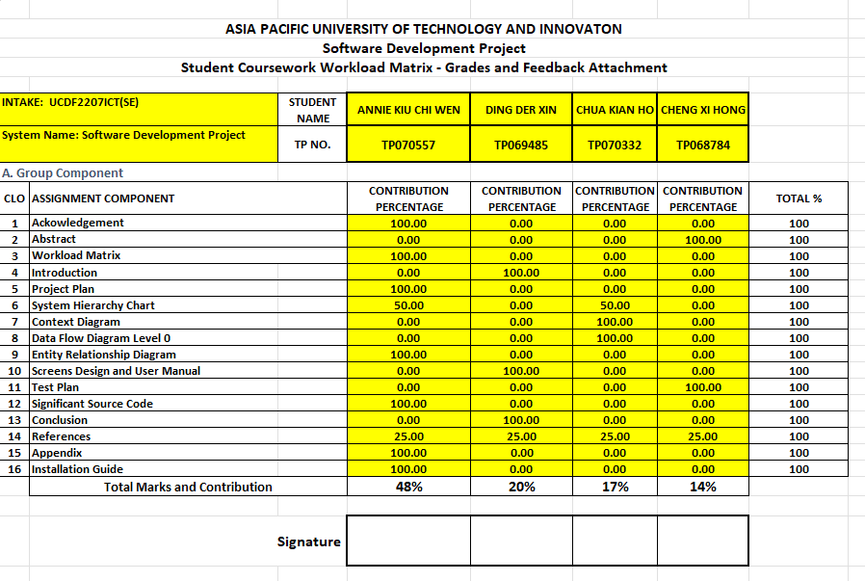

# 3.0 Introduction

## 3.1 Project Background

The Educational Goat (EDG) is to set an e-learning platform for individuals that are affected by colour blindness. These individuals face multiple difficulties in their everyday life that people with normal vision just aren’t aware of. These problems can arise from simply preparing food, driving a car, or even just from selecting clothes to wear. In addition, work that requires searching for information from different websites could also be a challenge due to the color range chosen for the interface. Most importantly, this situation can be overlooked easily especially for school children who are struggling in classroom due to the lack of awareness of the effect of it by both the parents and teachers. (Colour Blind Awareness, 2022)

3.2 Problem Context

In this modern society that relies deeply on visual indication for websites, partial colour blindness individuals that have protanopia and tritanopia are not easily identified. The difficulty faced by the two most seen visual impairments have difficulties in differentiating several colors. Protanopia suffers from differentiating red, green, blue and green, while tritanopia has difficulties differentiating blue and green, purple and red and yellow and pink. A lot of websites and applications utilize colours to provide information or distinguish between different elements, such as buttons, links, or status indicators (e.g., green for confirmation, red for faults). It may be challenging to discriminate between these elements if you have protanopia or tritanopia, which could cause confusion or misinterpretation. Moreover, it can be difficult to use user interfaces that rely on colour contrasts or colour-specific hints for navigation. For example, menus or interactive features that change colour when hovered over may not be seen, which makes navigating the website or app challenging. Lastly, many websites and applications don't provide users with the ability to customize colour schemes and contrasts to suit their preferences. For those who are colour blind, the lack of such capabilities restricts accessibility and their overall experience using a device. (National Eye Institute, 2023)

## 3.3 Proposed Solution

Therefore, The Educational Goat main interface which excludes these confusing colours in terms of modes of the EDG website is an important goal of the team. Our team is dedicated to closing this important gap where these individuals cannot differentiate multiple items due to colour combinations on the interface. By implementing the method of incorporating design principles sensitive to the colour perception challenges of protanopia and tritanopia. The EDG project plans to make features that are available for them to adjust the colour scheme modes, with resizable texts and contrast colours that are designed to their needs. This method aims to ensure that colourblind students may use online learning resources and navigate them as successfully as their peers, in addition to making instructional content accessible. With these clear and straightforward objectives, the EDG project aims to design an intuitive user interface that can be tailored to meet individual learner needs, thereby eliminating the impediments to accessing educational content. (Colour Blind Awareness, 2022)

## 3.4 Project Objectives

The objective of The Educational Goat is to implement solution for color-coded information, navigation, and usability issues, and enhancing customizable option for a more inclusive digital environment that helps the students with color-blindness especially the one with protanopia and tritanopia on their academic resources. By giving the students, the abilities to customize choices to enhance visibility, comprehension and learning process, this will help them to adapt to their digital studies with their own visual styles. Ultimately this approach not only help the students with color vision deficiencies by addressing specific challenges they face in academic settings but also give the student the tools and support necessary to succeed in providing a broader culture of inclusive digital education.

## 3.5 Project Scope

### 3.5.1 User Research:

With the goal to fully understand the difficulties experienced by users with protanopia and tritanopia, particularly in the context of digital learning environments, the project will carry out specific research. The scope of this study is restricted to finding problems with digital platform navigation, content color coding, and customization possibilities in the EDG website. It won't cover more extensive cognitive or physical shortcomings.

### 3.5.2 Design & Development:

The development of the EDG platform will be focused on designing a user interface that reduces the need for color differentiation, which is essential for individuals who are color blind. This entails: Putting in place an interface that makes it possible to modify font sizes, contrast levels, and color schemes. Other than that, ensuring that the most recent recommendations for color blindness accessible are incorporated into all design and development stages.

### 3.5.3 Content Adaptation:

The scope involves developing new resources and modifying currently available instructional materials with an emphasis on accessibility for those who are colour-blind. For clarification, the avoidance of colour-exclusive indications will be given top priority in the content adaptation. This kind of adaptation is intended only to help students with colour vision impairments access education materials with ease.

### 3.5.4 User Feedback:

Users with colour vision impairments will be actively engaged for feedback in order to iteratively enhance the EDG platform. The platform's colour-blind user interface's usability, accessibility, and efficacy will be the main topics of this feedback loop. The feedback will be gathered mainly with the intention of making changes to the EDG platform's current structure; this may not include creating completely new features that have nothing to do with the needs of colour-blind students.

## 3.6 Chosen Methodology

For this project, our team has chosen to implement the Spiral Methodology, a dynamic and iterative approach that allows for continuous refinement and enhancement of the platform through phases of planning, risk analysis, engineering, and evaluation. This methodology ensures that each stage of development is adjusted according to the collected user feedback and risk mitigation strategies, ultimately leading to a robust and user-friendly e-learning platform best suited to the latest leading trends.

# 4.0 Project Plan

## 4.1 System Development Methodology - Spiral Methodology

### 4.1.1 Planning

In the initial phase of the EDG (Educational Goat) project, our main aim is to tailor a functional math E-learning Platform for individuals that have difficulties in terms of partial color blindness. To reach this purpose, research and investigations via online documentation has been conducted by our team to have a better understanding in identifying constraints or limitations.

The main activity of this phase is to find out the design criteria that are suitable to fit user needs in terms of enabling customization of the websites interface. For example, providing high contrast modes, resizable texts, and color modes. Furthermore, in the planning stage, our team has listed out the functionalities each part of the system could do or could not do for each entity. (Ayers, 2023)

### 4.1.2 Risk Analysis

Risk mitigation plays a crucial phase in the spiral methodology that is chosen, especially when designing for accessibility. The risk analysis phase for EDG involves analyzing the potential problems or limitations that may happen during the engineering phase of the EDG system. Throughout this phase, conducting research and investigations will be our team’s priority to gather appropriate information needed. By identifying the potential risks, problems that could hinder user interaction with the e-learning platform will be avoided, ensuring a more fluent user experience. (Kumar Pal, 2018)

Not just that, this phase will provide a clearer and more specific path for our team to analyze potential problems of the system’s functionality. This includes creating a feasible solution for each problem that our team may face during the programming phase. For example, EDG’s potential risk is the color combination implemented on the interface. Creating a comfortable and attractive environment that suits specific individuals is a challenge faced by our team. In addition, finding a tester for the EDG’s website could pose a risk for the testing stages. Thus, causing confusion and time wastage that could impact the entire progress of our team.

### 4.1.3 Engineering

Moving on to the engineering phase, the actual development of the EDG system will be implemented in this phase. The key aspects undertaken includes creating a flexible and intuitive user interface design that fulfils the needs of our users. The learning materials chosen should be shown clearly on the customised interface using the in-hand resources and technologies available to our team. To ensure consistency throughout the website, a main design of the system will first be developed for clearer insight of the idea. Another main activity in this phase is the testing cycles that ensures each created required functionality of the system works properly. Including unit testing with integration testing, system testing and user acceptance testing. (Pearson, 2017)

### 4.1.4 Evaluation

The flexibility of the spiral model provides our team an alternative path where our group can choose to repeat the phases from top again after this phase. This critical phase serves as a method for our team to identify loopholes, bugs or malfunctioning parts that may have been overlooked by our team. By exposing the EDG system as a demo state to the potential user groups, fresh eyes can give feedback in terms of the capability, efficiency, and ease of use of the created system. Our team will then gather all the information to plan for another cycle of the spiral methodology where adjustments to the system and documentation are needed.

## 4.2 Project Gantt Chart

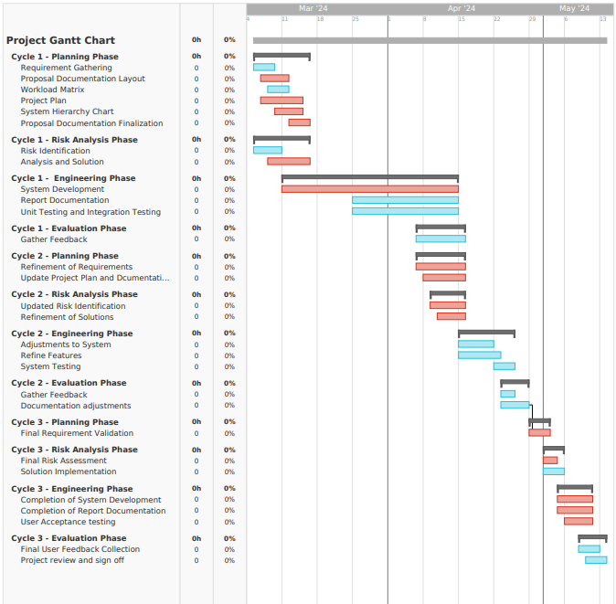

# 5.0 System Hierarchy Chart

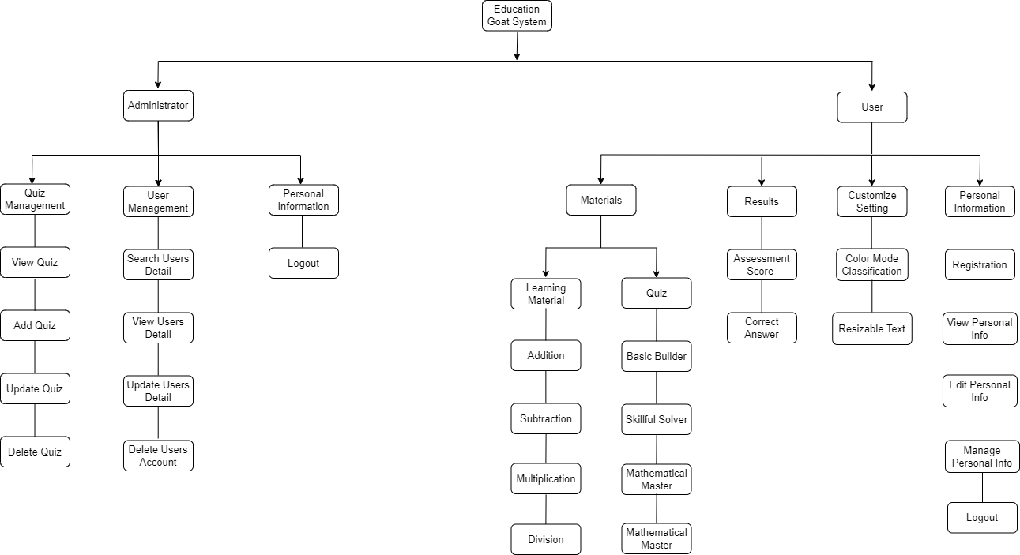

# 6.0 Context Diagram

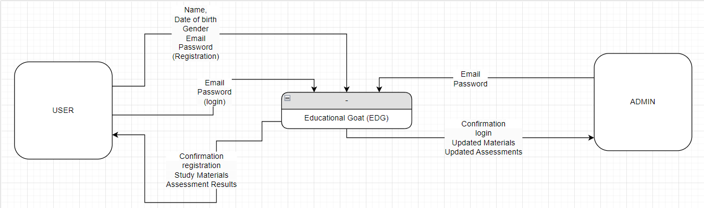

7.0 Data Flow Diagrams Level 0

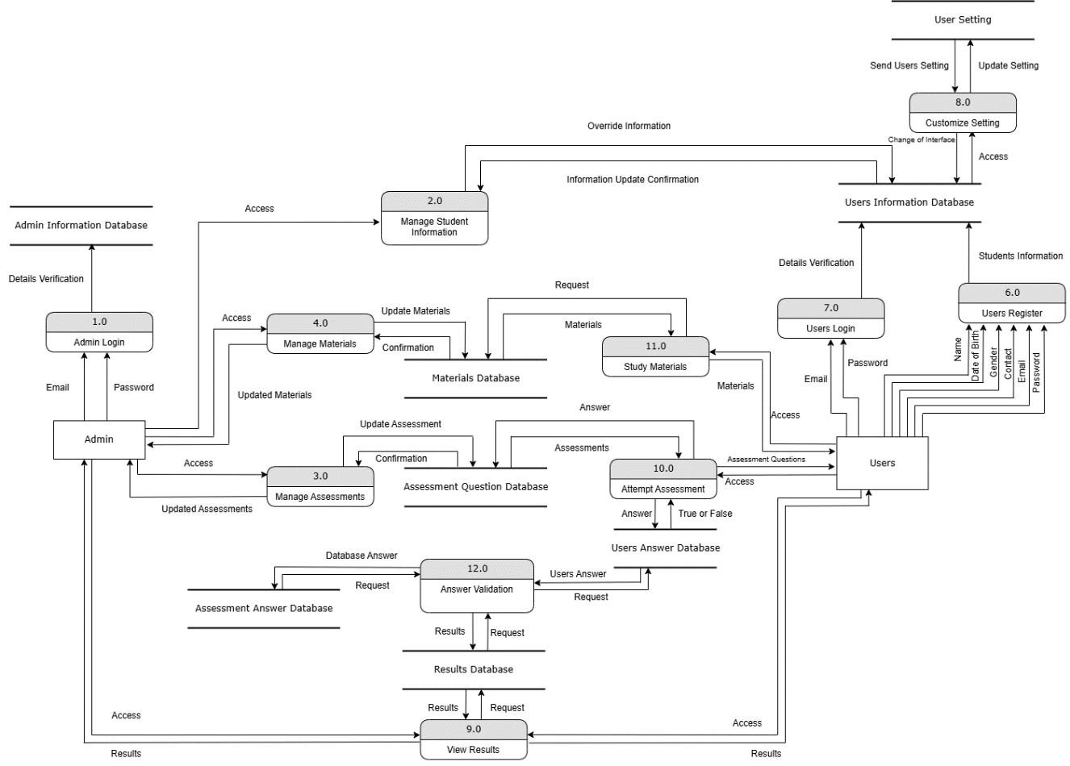

## 7.1 Data Flow Diagram Level 1

### 7.1.1 Annie Kiu Chi Wen (TP070557)

Manage Student Information

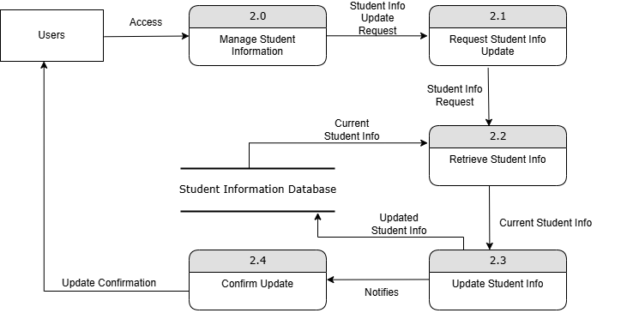

*DFD Level 1*

Process

|  |  |  |  |  |  |
| --- | --- | --- | --- | --- | --- |
| **Process ID** | **Process Name** | **Description** | **Inputs** | **Outputs** | **Data Stores** |
| 2.1 | |  | | --- | | Request Student Info Update |  |  | | --- | |  | | |  | | --- | | Receives request to update student information. |  |  | | --- | |  | | |  | | --- | | Student Info Update Request |  |  | | --- | |  | | |  | | --- | | Student Info Request Confirmation |  |  | | --- | |  | | |  | | --- | | None |  |  | | --- | |  | |
| 2.2 | |  | | --- | | Retrieve Student Info |  |  | | --- | |  | | |  | | --- | | Fetches current student information from database. |  |  | | --- | |  | | |  | | --- | | Student Info Request |  |  | | --- | |  | | |  | | --- | | Current Student Info |  |  | | --- | |  | | |  | | --- | | Student Information Database |  |  | | --- | |  | |
| 2.3 | |  | | --- | | Update Student Info |  |  | | --- | |  | | |  | | --- | | Updates the student information. |  |  | | --- | |  | | |  | | --- | | Current Student Info, Updated Student Info |  |  | | --- | |  | | |  | | --- | | Updated Student Info Confirmation |  |  | | --- | |  | | |  | | --- | | Student Information Database |  |  | | --- | |  | |
| 2.4 | |  | | --- | | Confirm Update |  |  | | --- | |  | | |  | | --- | | Confirms that the student information is updated. |  |  | | --- | |  | | |  | | --- | | Updated Student Info |  |  | | --- | |  | | |  | | --- | | Update Confirmation |  |  | | --- | |  | | None |

Data Flows

|  |  |  |  |  |  |  |  |  |  |
| --- | --- | --- | --- | --- | --- | --- | --- | --- | --- |
| |  | | --- | | **Data Flow ID** |  |  | | --- | |  | | |  | | --- | | **Data Flow Name** | | |  | | --- | | **Description** |  |  | | --- | |  | | **Source** | **Destination** |
| DF2.1 | |  | | --- | | Student Info Update Request |  |  | | --- | |  | | |  | | --- | | Request to update student information |  |  | | --- | |  | | |  | | --- | | Users |  |  | | --- | |  | | |  | | --- | | Request Student Info Update (2.1) |  |  | | --- | |  | |
| DF2.2 | |  | | --- | | Student Info Request Confirmation |  |  | | --- | |  | | |  | | --- | | Confirmation that update request is received |  |  | | --- | |  | | |  | | --- | | Request Student Info Update (2.1) |  |  | | --- | |  | | |  | | --- | | Users |  |  | | --- | |  | |
| DF2.3 | |  | | --- | | Student Info Request |  |  | | --- | |  | | |  | | --- | | Request to retrieve current student info |  |  | | --- | |  | | |  | | --- | | Request Student Info Update (2.1) |  |  | | --- | |  | | |  | | --- | | Retrieve Student Info (2.2) |  |  | | --- | |  | |
| DF2.4 | |  | | --- | | Current Student Info |  |  | | --- | |  | | |  | | --- | | Current student information fetched from database |  |  | | --- | |  | | |  | | --- | | Retrieve Student Info (2.2) |  |  | | --- | |  | | |  | | --- | | Update Student Info (2.3) |  |  | | --- | |  | |
| DF2.5 | |  | | --- | | Updated Student Info |  |  | | --- | |  | | |  | | --- | | Updated student information |  |  | | --- | |  | | |  | | --- | | Update Student Info (2.3) |  |  | | --- | |  | | |  | | --- | | Student Information Database |  |  | | --- | |  | |
| DF2.6 | |  | | --- | | Updated Student Info Confirmation |  |  | | --- | |  | | |  | | --- | | Confirmation that student info is updated |  |  | | --- | |  | | |  | | --- | | Update Student Info (2.3) |  |  | | --- | |  | | |  | | --- | | Confirm Update (2.4) |  |  | | --- | |  | |
| DF2.7 | |  | | --- | | Update Confirmation |  |  | | --- | |  | | |  | | --- | | Confirmation sent to users |  |  | | --- | |  | | |  | | --- | | Confirm Update (2.4) |  |  | | --- | |  | | Users |

Data Stores

|  |  |  |
| --- | --- | --- |
| **Data Store ID** | **Data Store Name** | **Description** |
| DS2.1 | |  | | --- | | Student Information Database |  |  | | --- | |  | | Stores student information including name, DOB, gender, etc. |

### 7.1.2 Chua Kian Ho (TP070332)

Manage Assessments

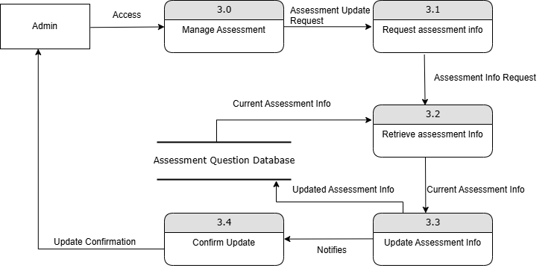

Process

|  |  |  |  |  |  |
| --- | --- | --- | --- | --- | --- |
| Process | Process Name | Description | Inputs | Outputs | Data Stores |
| 3.1 | |  | | --- | | Request Assessment Info |  |  | | --- | |  | | |  | | --- | | Receives request to update assessment info. |  |  | | --- | |  | | |  | | --- | | Assessment Update Request |  |  | | --- | |  | | |  | | --- | | Assessment Info Request Confirmation |  |  | | --- | |  | | |  | | --- | | None |  |  | | --- | |  | |
| 3.2 | |  | | --- | | Retrieve Assessment Info |  |  | | --- | |  | | |  | | --- | | Fetches current assessment info from database. |  |  | | --- | |  | | |  | | --- | | Assessment Info Request |  |  | | --- | |  | | |  | | --- | | Current Assessment Info |  |  | | --- | |  | | |  | | --- | | Assessment Question Database |  |  | | --- | |  | |
| 3.3 | |  | | --- | | Update Assessment Info |  |  | | --- | |  | | |  | | --- | | Updates the assessment information. |  |  | | --- | |  | | |  | | --- | | Current Assessment Info, Updated Assessment Info |  |  | | --- | |  | | |  | | --- | | Updated Assessment Info Confirmation |  |  | | --- | |  | | |  | | --- | | Assessment Question Database |  |  | | --- | |  | |
| 3.4 | |  | | --- | | Confirm Update |  |  | | --- | |  | | |  | | --- | | Confirms that the assessment information is updated. |  |  | | --- | |  | | |  | | --- | | Updated Assessment Info |  |  | | --- | |  | | |  | | --- | | Update Confirmation |  |  | | --- | |  | | None |

Data Flows

|  |  |  |  |  |  |  |  |  |  |
| --- | --- | --- | --- | --- | --- | --- | --- | --- | --- |
| |  | | --- | | **Data Flow ID** |  |  | | --- | |  | | |  | | --- | | **Data Flow Name** | | |  | | --- | | **Description** |  |  | | --- | |  | | Source | Destination |
| DF3.1 | |  |  |  | | --- | --- | --- | | |  | | --- | | Assessment Update Request |  |  | | --- | |  | |  |  | | --- | |  | | |  |  |  | | --- | --- | --- | | |  | | --- | | Request to update assessment information |  |  | | --- | |  | |  |  | | --- | |  | | |  | | --- | | Admin |  |  | | --- | |  | | |  |  |  | | --- | --- | --- | | |  | | --- | | Request Assessment Info (3.1) |  |  | | --- | |  | |  |  | | --- | |  | |
| DF3.2 | |  | | --- | | Assessment Info Request Confirmation |  |  | | --- | |  | | |  |  |  | | --- | --- | --- | | |  | | --- | | Confirmation that update request is received |  |  | | --- | |  | |  |  | | --- | |  | | |  |  |  | | --- | --- | --- | | |  | | --- | | Request Assessment Info (3.1) |  |  | | --- | |  | |  |  | | --- | |  | | |  |  |  | | --- | --- | --- | | |  | | --- | | Admin |  |  | | --- | |  | |  |  | | --- | |  | |
| |  | | --- | | DF3.3 |  |  | | --- | |  | | |  |  |  | | --- | --- | --- | | |  | | --- | | Assessment Info Request |  |  | | --- | |  | |  |  | | --- | |  | | |  |  |  | | --- | --- | --- | | |  | | --- | | Request to retrieve current assessment info |  |  | | --- | |  | |  |  | | --- | |  | | |  |  |  | | --- | --- | --- | | |  | | --- | | Request Assessment Info (3.1) |  |  | | --- | |  | |  |  | | --- | |  | | |  |  |  | | --- | --- | --- | | |  | | --- | | Retrieve Assessment Info (3.2) |  |  | | --- | |  | |  |  | | --- | |  | |
| |  | | --- | | DF3.4 |  |  | | --- | |  | | |  |  |  | | --- | --- | --- | | |  | | --- | | Current Assessment Info |  |  | | --- | |  | |  |  | | --- | |  | | |  |  |  | | --- | --- | --- | | |  | | --- | | Current assessment information fetched from database |  |  | | --- | |  | |  |  | | --- | |  | | |  |  |  | | --- | --- | --- | | |  | | --- | | Retrieve Assessment Info (3.2) |  |  | | --- | |  | |  |  | | --- | |  | | |  |  |  | | --- | --- | --- | | |  | | --- | | Update Assessment Info (3.3) |  |  | | --- | |  | |  |  | | --- | |  | |
| DF3.5 | |  |  |  | | --- | --- | --- | | |  | | --- | | Updated Assessment Info |  |  | | --- | |  | |  |  | | --- | |  | | |  |  |  | | --- | --- | --- | | |  | | --- | | Updated assessment information |  |  | | --- | |  | |  |  | | --- | |  | | |  |  |  | | --- | --- | --- | | |  | | --- | | Update Assessment Info (3.3) |  |  | | --- | |  | |  |  | | --- | |  | | |  |  |  | | --- | --- | --- | | |  | | --- | | Assessment Question Database |  |  | | --- | |  | |  |  | | --- | |  | |
| DF3.6 | |  |  |  | | --- | --- | --- | | |  | | --- | | Updated Assessment Info Confirmation |  |  | | --- | |  | |  |  | | --- | |  | | |  |  |  | | --- | --- | --- | | |  | | --- | | Confirmation that assessment info is updated |  |  | | --- | |  | |  |  | | --- | |  | | |  |  |  | | --- | --- | --- | | |  | | --- | | Update Assessment Info (3.3) |  |  | | --- | |  | |  |  | | --- | |  | | |  |  |  | | --- | --- | --- | | |  | | --- | | Confirm Update (3.4) |  |  | | --- | |  | |  |  | | --- | |  | |
| DF3.7 | |  |  |  | | --- | --- | --- | | |  | | --- | | Update Confirmation |  |  | | --- | |  | |  |  | | --- | |  | | |  |  |  | | --- | --- | --- | | |  | | --- | | Confirmation sent to admin |  |  | | --- | |  | |  |  | | --- | |  | | |  |  |  | | --- | --- | --- | | |  | | --- | | Confirm Update (3.4) |  |  | | --- | |  | |  |  | | --- | |  | | Admin |

Data Stores

|  |  |  |
| --- | --- | --- |
| Data Store ID | Data Store Name | Description |
| |  | | --- | | DS3.1 |  |  | | --- | |  | | |  | | --- | | Assessment Question Database |  |  | | --- | |  | | Stores assessment questions and related information |

### 7.1.3 Ding Der Xin (TP069485)

Process 6.1 and 6.2: User Registration

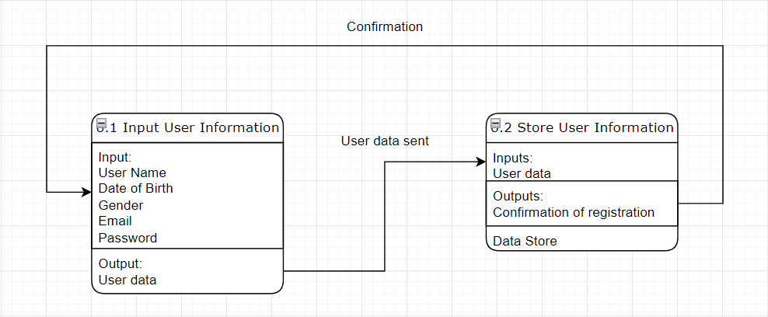

|  |  |  |  |  |
| --- | --- | --- | --- | --- |
| Data Flow |  |  |  |  |
|  |  |  |  |  |
| **Data Flow** | **Description** | **Attributes** | **Source** | **Destination** |
| User Information | Data entered by the user during registration. | Username, Date of Birth, Gender, Email, Password | User input | Input User Information process |
| User Data Sent | The complete user data after being processed. | Username, Date of Birth, Gender, Email, Password | Input User Information process | Store User Information process |
| Confirmation | Confirmation message sent to the user after registration. | Confirmation message (e.g., "Registration successful") | Store User Information process | User |

Process

|  |  |  |  |  |  |
| --- | --- | --- | --- | --- | --- |
| **Process ID** | **Process Name** | **Description** | **Input** | **Output** | **Transformation** |
| 6.1 | Input User Information | Collects registration details from the user. | Username, Date of Birth, Gender, Email, Password | User data | Gathers user input data. |
| 6.2 | Store User Information | Stores the user information and sends a confirmation message. | User data | Confirmation of registration | Stores user data into the database and sends confirmation. |

|  |  |  |  |
| --- | --- | --- | --- |
| Data Store |  |  |  |
|  |  |  |  |
| **Data Store** | **Description** | **Attributes** | **Processes that interact with it** |
| Student Information Database | Database where all user information is stored. | Username, Date of Birth, Gender, Email, Password | Store User Information process (input) |

### 7.1.4 Cheng Xi Hong (TP068784)

Admin Login

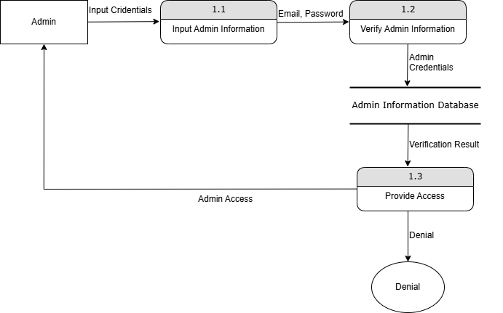

Process

|  |  |  |  |  |  |
| --- | --- | --- | --- | --- | --- |
| **Process ID** | **Process Name** | **Description** | **Inputs** | **Outputs** | **Data Stores** |
| 1.1 | Input Admin Info | |  | | --- | | Admin enters email and password. |  |  | | --- | |  | | |  | | --- | | Email, Password |  |  | | --- | |  | | |  | | --- | | Admin Credentials |  |  | | --- | |  | | |  | | --- | | None |  |  | | --- | |  | |
| 1.2 | |  | | --- | | Verify Admin Info |  |  | | --- | |  | | |  | | --- | | Verifies admin credentials against database. |  |  | | --- | |  | | |  | | --- | | Admin Credentials |  |  | | --- | |  | | |  | | --- | | Verification Result |  |  | | --- | |  | | |  | | --- | | Admin Information Database |  |  | | --- | |  | |
| 1.3 | |  | | --- | | Provide Access |  |  | | --- | |  | | |  | | --- | | Verifies admin credentials against database. |  |  | | --- | |  | | |  | | --- | | Verification Result |  |  | | --- | |  | | |  | | --- | | Admin Access, Denial |  |  | | --- | |  | | None |

Data Flows

|  |  |  |  |  |  |  |  |  |  |  |
| --- | --- | --- | --- | --- | --- | --- | --- | --- | --- | --- |
| |  | | --- | | **Data Flow ID** |  |  | | --- | |  | | |  | | --- | | **Data Flow Name** |  |  | | --- | |  | | |  | | --- | | **Description** |  |  | | --- | |  | | **Source** | **Destination** |
| DF1.1 | Email | |  | | --- | | Admin's email address entered during login |  |  | | --- | |  | | |  | | --- | | Admin |  |  | | --- | |  | | |  | | --- | | Input Admin Info (1.1) |  |  | | --- | |  | |
| DF1.2 | Password | |  | | --- | | Admin's password entered during login |  |  | | --- | |  | | Admin | |  | | --- | | Input Admin Info (1.1) |  |  | | --- | |  | |
| DF1.3 | |  | | --- | | Admin Credentials |  |  | | --- | |  | | |  | | --- | | Credentials comprising email and password |  |  | | --- | |  | | |  | | --- | | Input Admin Info (1.1) |  |  | | --- | |  | | |  | | --- | | Verify Admin Info (1.2) |  |  | | --- | |  | |
| DF1.4 | |  | | --- | | Verification Result |  |  | | --- | |  | | |  | | --- | | Result of credential verification (valid/invalid) |  |  | | --- | |  | | |  | | --- | | Verify Admin Info (1.2) |  |  | | --- | |  | | |  | | --- | | Provide Access (1.3) |  |  | | --- | |  | |
| DF1.5 | |  | | --- | | Admin Access |  |  | | --- | |  | | |  | | --- | | Access granted to admin if credentials are valid |  |  | | --- | |  | | |  | | --- | | Provide Access (1.3) |  |  | | --- | |  | | Admin |
| DF1.6 | Denial | |  | | --- | | Access denied if credentials are invalid |  |  | | --- | |  | | |  | | --- | | Provide Access (1.3) |  |  | | --- | |  | | Admin |

Data Stores

|  |  |  |  |  |  |  |  |  |
| --- | --- | --- | --- | --- | --- | --- | --- | --- |
| |  | | --- | | **Data Store ID** |  |  | | --- | |  | | |  | | --- | | **Data Store Name** |  |  | | --- | |  | | | **Description** | | --- |  |  | | --- | |  | |
| |  | | --- | | DS1.1 |  |  | | --- | |  | | |  | | --- | | Admin Information Database |  |  | | --- | |  | | Stores admin login credentials (email and password) for verification |

## 7.2 Data Dictionary

### 7.2.1 Process

|  |  |  |  |  |
| --- | --- | --- | --- | --- |
| **Process ID** | **Process Name** | **Description** | **Input** | **Output** |
| 1.0 | Admin Login | |  | | --- | | Validates admin login details. |  |  | | --- | |  | | |  | | --- | | Email, Password | | |  | | --- | | Confirmation of Admin Login | |
| 2.0 | |  | | --- | | Manage Student Information |  |  | | --- | |  | | |  | | --- | | Manages user information including updates. |  |  | | --- | |  | | |  | | --- | | Request |  |  | | --- | |  | | |  | | --- | | Updated Information, Confirmation |  |  | | --- | |  | |
| 3.0 | |  | | --- | | Manage Assessments |  |  | | --- | |  | | |  |  |  | | --- | --- | --- | | |  | | --- | | Manages creation and updates of assessments |  |  | | --- | |  | |  |  | | --- | |  | | |  |  |  | | --- | --- | --- | | |  | | --- | | Updated Assessments |  |  | | --- | |  | |  |  | | --- | |  | | |  | | --- | | Confirmation of Updated Assessments |  |  | | --- | |  | |
| 4.0 | |  | | --- | | Manage Materials |  |  | | --- | |  | | |  | | --- | | Manages creation and updates of study materials. |  |  | | --- | |  | | |  | | --- | | Updated Materials |  |  | | --- | |  | | |  | | --- | | Confirmation of Updated Materials |  |  | | --- | |  | |
| 5.0 | |  | | --- | | Manage Results |  |  | | --- | |  | | |  | | --- | | Manages and views assessment results. |  |  | | --- | |  | | |  | | --- | | Access |  |  | | --- | |  | | |  | | --- | | Accessed Results |  |  | | --- | |  | |
| 6.0 | |  | | --- | | Users Register |  |  | | --- | |  | | |  | | --- | | Registers new users. |  |  | | --- | |  | | |  | | --- | | Username, Date of Birth, Gender, Email, Password |  |  | | --- | |  | | |  |  |  | | --- | --- | --- | | |  | | --- | | Confirmation of User Registration |  |  | | --- | |  | |  |  | | --- | |  | |
| 7.0 | |  | | --- | | Users Login |  |  | | --- | |  | | |  | | --- | | Validates user login details. |  |  | | --- | |  | | |  | | --- | | Email, Password |  |  | | --- | |  | | |  | | --- | | Confirmation of User Login |  |  | | --- | |  | |
| 8.0 | |  | | --- | | Customize Setting |  |  | | --- | |  | | |  | | --- | | Allows users to customize settings. |  |  | | --- | |  | | |  | | --- | | Updated User Settings |  |  | | --- | |  | | |  | | --- | | Confirmation of Updated Settings |  |  | | --- | |  | |
| 9.0 | |  | | --- | | View Results |  |  | | --- | |  | | |  | | --- | | Allows users to view their assessment results. |  |  | | --- | |  | | Access | |  | | --- | | Accessed Results |  |  | | --- | |  | |
| 10.0 | |  | | --- | | Attempt Assessment |  |  | | --- | |  | | |  | | --- | | Users attempt assessments. |  |  | | --- | |  | | |  | | --- | | Accessed Assessments |  |  | | --- | |  | | |  | | --- | | Assessment Records |  |  | | --- | |  | |
| 11.0 | |  | | --- | | Study Materials |  |  | | --- | |  | | |  | | --- | | Provides access to study materials. |  |  | | --- | |  | | |  | | --- | | Access |  |  | | --- | |  | | |  | | --- | | Accessed Materials |  |  | | --- | |  | |
| |  | | --- | | 12.0 |  |  | | --- | |  | | |  | | --- | | Answer Validation |  |  | | --- | |  | | |  | | --- | | Validates user answers to assessments. |  |  | | --- | |  | | |  | | --- | | User Answers |  |  | | --- | |  | | Results |

### 7.2.2 Data Flow

|  |  |  |  |  |
| --- | --- | --- | --- | --- |
| **Data Flow** | **Description** | **Attributes** | **Source** | **Destination** |
| Admin Login Details | |  | | --- | | Information entered by the admin to log in. |  |  | | --- | |  | | |  | | --- | | Email, Password |  |  | | --- | |  | | |  | | --- | | Admin |  |  | | --- | |  | | |  | | --- | | Admin Login Process |  |  | | --- | |  | |
| |  | | --- | | Confirmation of Admin Login |  |  | | --- | |  | | |  | | --- | | Confirmation message after admin logs in successfully. |  |  | | --- | |  | | |  | | --- | | Confirmation message |  |  | | --- | |  | | |  | | --- | | Admin Login Process |  |  | | --- | |  | | |  | | --- | | Admin |  |  | | --- | |  | |
| |  | | --- | | Updated Materials |  |  | | --- | |  | | |  | | --- | | New or updated materials provided by admin. |  |  | | --- | |  | | |  | | --- | | Material details, Material ID |  |  | | --- | |  | | |  | | --- | | Manage Materials Process |  |  | | --- | |  | | |  | | --- | | Materials Database |  |  | | --- | |  | |
| |  | | --- | | Confirmation of Updated Materials |  |  | | --- | |  | | |  | | --- | | Confirmation message after materials are updated. |  |  | | --- | |  | | |  | | --- | | Confirmation message |  |  | | --- | |  | | |  | | --- | | Materials Database |  |  | | --- | |  | | |  | | --- | | Manage Materials Process |  |  | | --- | |  | |
| |  | | --- | | Updated Assessments |  |  | | --- | |  | | |  | | --- | | New or updated assessments provided by admin. |  |  | | --- | |  | | |  | | --- | | Assessment details, Assessment ID |  |  | | --- | |  | | |  | | --- | | Manage Assessments Process |  |  | | --- | |  | | |  | | --- | | Assessment Database |  |  | | --- | |  | |
| |  | | --- | | Confirmation of Updated Assessments |  |  | | --- | |  | | |  | | --- | | Confirmation message after assessments is updated. |  |  | | --- | |  | | |  | | --- | | Confirmation message |  |  | | --- | |  | | |  | | --- | | Assessment Database |  |  | | --- | |  | | |  | | --- | | Manage Assessments Process |  |  | | --- | |  | |
| |  | | --- | | Accessed Assessments |  |  | | --- | |  | | |  | | --- | | Assessment questions accessed by users. |  |  | | --- | |  | | |  | | --- | | Assessment questions |  |  | | --- | |  | | |  | | --- | | Assessment Database |  |  | | --- | |  | | |  | | --- | | Attempt Assessment Process |  |  | | --- | |  | |
| |  | | --- | | Assessment Records |  |  | | --- | |  | | |  | | --- | | Results of attempted assessments. |  |  | | --- | |  | | |  | | --- | | User ID, Assessment ID, Answers, Scores |  |  | | --- | |  | | |  | | --- | | Attempt Assessment Process |  |  | | --- | |  | | |  | | --- | | Results Database |  |  | | --- | |  | |
| |  | | --- | | User Login Details |  |  | | --- | |  | | |  | | --- | | Information entered by the user to log in. |  |  | | --- | |  | | |  | | --- | | Email, Password |  |  | | --- | |  | | |  | | --- | | User |  |  | | --- | |  | | |  | | --- | | Users Login Process |  |  | | --- | |  | |
| |  | | --- | | Confirmation of User Login |  |  | | --- | |  | | |  | | --- | | Confirmation message after user logs in successfully. |  |  | | --- | |  | | |  | | --- | | Confirmation message |  |  | | --- | |  | | |  | | --- | | Users Login Process |  |  | | --- | |  | | |  | | --- | | User |  |  | | --- | |  | |
| |  | | --- | | Registered User Information |  |  | | --- | |  | | |  | | --- | | New user information entered during registration. |  |  | | --- | |  | | |  | | --- | | Username, Date of Birth, Gender, Email, Password |  |  | | --- | |  | | |  | | --- | | User |  |  | | --- | |  | | |  | | --- | | Users Register Process |  |  | | --- | |  | |
| |  | | --- | | Confirmation of User Registration |  |  | | --- | |  | | |  | | --- | | Confirmation message after successful registration. |  |  | | --- | |  | | |  | | --- | | Confirmation message |  |  | | --- | |  | | |  | | --- | | Users Register Process |  |  | | --- | |  | | User |
| |  | | --- | | Accessed Materials |  |  | | --- | |  | | |  | | --- | | Study materials accessed by users. |  |  | | --- | |  | | |  | | --- | | Material details |  |  | | --- | |  | | |  | | --- | | Materials Database |  |  | | --- | |  | | |  | | --- | | Study Materials Process |  |  | | --- | |  | |
| |  | | --- | | Accessed Results |  |  | | --- | |  | | |  | | --- | | Results of assessments accessed by users. |  |  | | --- | |  | | |  | | --- | | Assessment details, Scores |  |  | | --- | |  | | |  | | --- | | Results Database |  |  | | --- | |  | | |  | | --- | | View Results Process |  |  | | --- | |  | |
| |  | | --- | | Updated User Settings |  |  | | --- | |  | | |  | | --- | | User settings updated by users. |  |  | | --- | |  | | |  | | --- | | User settings |  |  | | --- | |  | | |  | | --- | | Customize Setting Process |  |  | | --- | |  | | |  | | --- | | User Setting |  |  | | --- | |  | |
| |  | | --- | | Confirmation of Updated Settings |  |  | | --- | |  | | |  | | --- | | Confirmation message after settings is updated. |  |  | | --- | |  | | |  | | --- | | Confirmation message |  |  | | --- | |  | | |  | | --- | | User Setting |  |  | | --- | |  | | Customize Setting Process |

### 7.2.3 Data Store

|  |  |  |  |  |  |  |  |
| --- | --- | --- | --- | --- | --- | --- | --- |
| |  | | --- | | **Data Store ID** |  |  | | --- | |  | | |  | | --- | | **Data Store Name** |  |  | | --- | |  | | **Description** | **Attributes** |
| DS1 | |  | | --- | | Admin Information Database |  |  | | --- | |  | | |  | | --- | | Stores admin login details. |  |  | | --- | |  | | |  | | --- | | Email, Password |  |  | | --- | |  | |
| DS2 | |  | | --- | | Student Information Database |  |  | | --- | |  | | |  | | --- | | Stores user registration details. |  |  | | --- | |  | | |  | | --- | | Username, Date of Birth, Gender, Email, Password |  |  | | --- | |  | |
| DS3 | |  | | --- | | Materials Database |  |  | | --- | |  | | |  | | --- | | Stores study materials. |  |  | | --- | |  | | |  | | --- | | Material ID, Material details |  |  | | --- | |  | |
| DS4 | |  | | --- | | Assessment Database |  |  | | --- | |  | | |  | | --- | | Stores assessment questions and records. |  |  | | --- | |  | | |  | | --- | | Assessment ID, Assessment details, User answers, Scores |  |  | | --- | |  | |
| DS5 | |  | | --- | | Results Database |  |  | | --- | |  | | |  | | --- | | Stores assessment results. |  |  | | --- | |  | | |  | | --- | | User ID, Assessment ID, Scores |  |  | | --- | |  | |
| DS6 | |  | | --- | | User Setting |  |  | | --- | |  | | |  | | --- | | Stores user customization settings. |  |  | | --- | |  | | User settings |

# 8.0 Entity Relationship Diagram

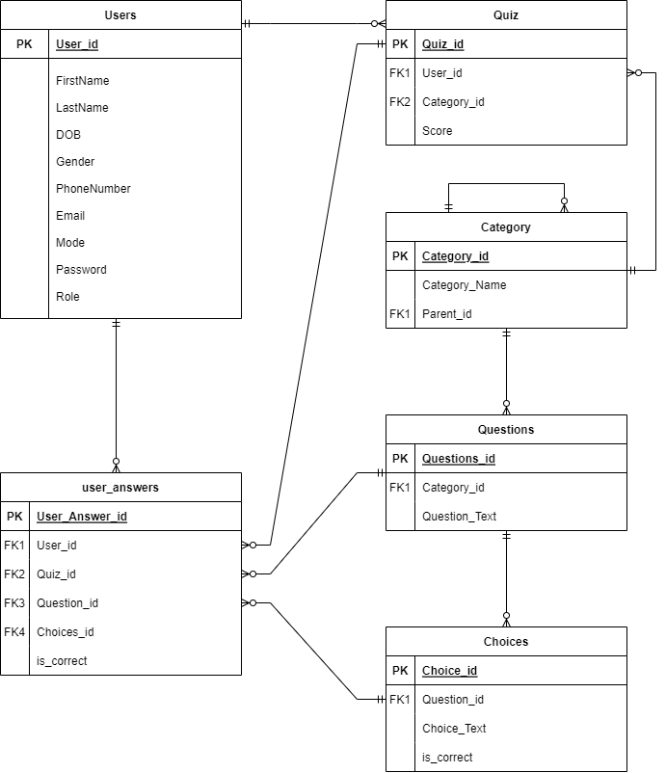

# 9.0 Pseudocode

## 9.1 Annie Kiu Chi Wen (TP070557)

PHP.file

**Title: Add Quiz**

BEGIN Add_Quiz

IMPORT necessary files and libraries

INCLUDE session start

CHECK user authentication

IF user not authenticated

REDIRECT to login page

CONNECT to the database

RETRIEVE list of quizzes from database

IF form is submitted

RETRIEVE form data

INSERT new quiz data into database

REDIRECT to quiz management page

DISPLAY form for adding a new quiz

END Add_Quiz

**Title: Choose Quiz**

BEGIN choose_quiz

IMPORT necessary files and libraries

INCLUDE session start

CHECK user authentication

IF user not authenticated

REDIRECT to login page

CONNECT to the database

RETRIEVE list of available quizzes

DISPLAY available quizzes to user

END choose_quiz

**Title: Database Connection**

BEGIN conn

DEFINE database connection parameters (host, username, password, database)

ESTABLISH connection to the database using parameters

IF connection fails

DISPLAY error message

END conn

**Title: Edit Profile**

BEGIN Edit_Profile

IMPORT necessary files and libraries

INCLUDE session start

CHECK user authentication

IF user not authenticated

REDIRECT to login page

CONNECT to the database

RETRIEVE user profile information

IF form is submitted

RETRIEVE form data

UPDATE user profile information in database

REDIRECT to profile page

DISPLAY form for editing profile information

END Edit_Profile

**Title: Edit Quiz**

BEGIN Edit_Quiz

IMPORT necessary files and libraries

INCLUDE session start

CHECK user authentication

IF user not authenticated

REDIRECT to login page

CONNECT to the database

RETRIEVE quiz information based on quiz ID

IF form is submitted

RETRIEVE form data

UPDATE quiz information in database

REDIRECT to quiz management page

DISPLAY form for editing quiz information

END Edit_Quiz

Title: Forgot Password

BEGIN forgot_password

IMPORT necessary files and libraries

CONNECT to the database

IF form is submitted

RETRIEVE form data (email)

CHECK if email exists in the database

IF email exists

GENERATE password reset token

SAVE token in database

SEND password reset email to user

DISPLAY form for entering email to reset password

END forgot_password

Title: Login Check

BEGIN login_check

IMPORT necessary files and libraries

CONNECT to the database

IF form is submitted

RETRIEVE form data (username, password)

VALIDATE username and password

IF credentials are valid

START user session

REDIRECT to dashboard

ELSE

DISPLAY error message

END login_check

Title: Logout

BEGIN logout

INCLUDE session start

DESTROY user session

REDIRECT to login page

END logout

Title: Manage User

BEGIN manage_user

IMPORT necessary files and libraries

INCLUDE session start

CHECK user authentication

IF user not authenticated

REDIRECT to login page

CONNECT to the database

RETRIEVE list of users

DISPLAY user management interface

IF delete action is triggered

DELETE specified user from database

END manage_user

Title: Pick Color

BEGIN pick_color

IMPORT necessary files and libraries

INCLUDE session start

CHECK user authentication

IF user not authenticated

REDIRECT to login page

CONNECT to the database

IF form is submitted

RETRIEVE form data (selected color)

SAVE selected color in database

DISPLAY color picking interface

END pick_color

Title: Pick Size

BEGIN pick_size

IMPORT necessary files and libraries

INCLUDE session start

CHECK user authentication

IF user not authenticated

REDIRECT to login page

CONNECT to the database

IF form is submitted

RETRIEVE form data (selected size)

SAVE selected size in database

DISPLAY size picking interface

END pick_size

Title: Quiz

BEGIN quiz

IMPORT necessary files and libraries

INCLUDE session start

CHECK user authentication

IF user not authenticated

REDIRECT to login page

CONNECT to the database

RETRIEVE quiz questions

DISPLAY quiz questions to user

IF form is submitted

RETRIEVE form data (user answers)

GRADE user answers

SAVE results in database

DISPLAY quiz results

END quiz

## 9.2 Chua Kian Ho (TP

Title: Reset Password

BEGIN reset_password

IMPORT necessary files and libraries

CONNECT to the database

VALIDATE password reset token

IF form is submitted

RETRIEVE form data (new password)

UPDATE password in database

REDIRECT to login page

DISPLAY form for entering new password

END reset_passwor

Title: Submit Form

BEGIN submit_form

IMPORT necessary files and libraries

CONNECT to the database

IF form is submitted

RETRIEVE form data

PROCESS form data (e.g., save to database, perform calculations)

REDIRECT or DISPLAY confirmation message

DISPLAY form to user

END submit_form

HTML.file

Title: Addition

BEGIN Addition

IMPORT necessary files and libraries

INCLUDE session start

CHECK user authentication

IF user not authenticated

REDIRECT to login page

CONNECT to the database

RETRIEVE list of addition questions

DISPLAY addition questions to user

IF form is submitted

RETRIEVE form data (user answers)

GRADE user answers

SAVE results in database

DISPLAY addition quiz results

END Addition

Title: Admin Dashboard

BEGIN Admin_Dashboard

IMPORT necessary files and libraries

INCLUDE session start

CHECK user authentication

IF user not authenticated

REDIRECT to login page

DISPLAY admin dashboard with options:

- Manage Users

- Manage Quiz

- User Scores

- Log Out

IF log out is clicked

DISPLAY confirmation modal

IF confirmed

LOG OUT user

END Admin_Dashboard

Title: Admin Quiz

BEGIN Admin_Quiz

IMPORT necessary files and libraries

INCLUDE session start

CHECK user authentication

IF user not authenticated

REDIRECT to login page

CONNECT to the database

RETRIEVE list of quizzes

DISPLAY quiz management interface

IF delete action is triggered

DELETE specified quiz from database

END Admin_Quiz

Title: Admin Results

BEGIN Admin_Results

IMPORT necessary files and libraries

INCLUDE session start

CHECK user authentication

IF user not authenticated

REDIRECT to login page

CONNECT to the database

RETRIEVE list of user quiz results

DISPLAY user quiz results

END Admin_Results

Title: Admin Users

BEGIN Admin_Users

IMPORT necessary files and libraries

INCLUDE session start

CHECK user authentication

IF user not authenticated

REDIRECT to login page

CONNECT to the database

RETRIEVE list of users

DISPLAY user management interface

IF delete action is triggered

DELETE specified user from database

END Admin_Users

Title: Choose Quiz

BEGIN Choose_Quiz

IMPORT necessary files and libraries

INCLUDE session start

CHECK user authentication

IF user not authenticated

REDIRECT to login page

CONNECT to the database

RETRIEVE list of available quizzes

DISPLAY available quizzes to user

END Choose_Quiz

Title: Main Dashboard

BEGIN Dashboard

IMPORT necessary files and libraries

INCLUDE session start

CHECK user authentication

IF user not authenticated

REDIRECT to login page

DISPLAY main dashboard with sections:

- Materials

- Quiz

- About Us

- Settings

IF settings is clicked

DISPLAY confirmation modal

IF confirmed

LOG OUT user

END Dashboard

## 9.3 Ding Der Xin

Title: Division

BEGIN Division

IMPORT necessary files and libraries

INCLUDE session start

CHECK user authentication

IF user not authenticated

REDIRECT to login page

CONNECT to the database

RETRIEVE list of division questions

DISPLAY division questions to user

IF form is submitted

RETRIEVE form data (user answers)

GRADE user answers

SAVE results in database

DISPLAY division quiz results

END Division

Title: Forgot Password Page

BEGIN Forgot_Password

IMPORT necessary files and libraries

INCLUDE form for entering email to reset password

FORM submission action to 'forgot_password.php'

DISPLAY form for entering email

JAVASCRIPT validation for email input

END Forgot_Password

Title: Login Page

BEGIN Login

IMPORT necessary files and libraries

INCLUDE form for entering email and password to log in

FORM submission action to 'login_check.php'

DISPLAY form for entering email and password

JAVASCRIPT validation for email and password input

LINK to sign up and forgot password pages

END Login

Title: Multiplication

BEGIN Multiplication

IMPORT necessary files and libraries

INCLUDE session start

CHECK user authentication

IF user not authenticated

REDIRECT to login page

CONNECT to the database

RETRIEVE list of multiplication questions

DISPLAY multiplication questions to user

IF form is submitted

RETRIEVE form data (user answers)

GRADE user answers

SAVE results in database

DISPLAY multiplication quiz results

END Multiplication

Title: Pick Color Mode

BEGIN Pick_Color

IMPORT necessary files and libraries

DISPLAY options for selecting color mode:

- Protanopia mode

- Tritanopia mode

DISPLAY form for color mode selection

FORM submission action to 'pick_color.php'

JAVASCRIPT to change background color on image hover

END Pick_Color

Title: Pick Text Size

BEGIN Pick_Size

IMPORT necessary files and libraries

DISPLAY options for selecting text size:

- Small

- Medium

- Large

DISPLAY form for text size selection

FORM submission action to 'pick_size.php'

END Pick_Size

Title: Profile Page

BEGIN Profile_Page

IMPORT necessary files and libraries

INCLUDE session start

CHECK user authentication

IF user not authenticated

REDIRECT to login page

CONNECT to the database

RETRIEVE user profile information

DISPLAY user profile information

IF form is submitted

RETRIEVE form data

UPDATE user profile information in database

REDIRECT to profile page

END Profile_Page

Title: Quiz

BEGIN Quiz

IMPORT necessary files and libraries

INCLUDE session start

CHECK user authentication

IF user not authenticated

REDIRECT to login page

CONNECT to the database

RETRIEVE quiz questions

DISPLAY quiz questions to user

IF form is submitted

RETRIEVE form data (user answers)

GRADE user answers

SAVE results in database

DISPLAY quiz results

END Quiz

Title: Quiz Answers

BEGIN Quiz_Answers

IMPORT necessary files and libraries

INCLUDE session start

CHECK user authentication

IF user not authenticated

REDIRECT to login page

CONNECT to the database

RETRIEVE quiz answers based on quiz ID

DISPLAY quiz answers to user

END Quiz_Answers

Title: Reset Password Page

BEGIN Reset_Password

IMPORT necessary files and libraries

INCLUDE form for entering new password and confirming it

FORM submission action to 'reset_password.php'

DISPLAY form for entering new password and confirmation

JAVASCRIPT validation for password input

END Reset_Password

## 9.4 Cheng Xi Hong

**Title: Result**

BEGIN Result

IMPORT necessary files and libraries

INCLUDE session start

CHECK user authentication

IF user not authenticated

REDIRECT to login page

CONNECT to the database

RETRIEVE user results

DISPLAY user results

END Result

**Title: Sample Math Materials**

BEGIN Sample_Materials

IMPORT necessary files and libraries

DISPLAY sections for various math topics:

- Addition

- Subtraction

- Multiplication

- Division

INCLUDE images and explanations for each topic

JAVASCRIPT to handle modal for login prompt

END Sample_Materials

**Title: Signup Page**

BEGIN Signup

IMPORT necessary files and libraries

INCLUDE form for entering user details to sign up

FORM submission action to 'submit_form.php'

DISPLAY form for entering:

- First Name

- Last Name

- Date of Birth

- Gender

- Phone Number

- Email

- Password

- Confirm Password

JAVASCRIPT validation for form inputs

LINK to login page

END Signup

Title: Subtraction

BEGIN Subtraction

IMPORT necessary files and libraries

INCLUDE session start

CHECK user authentication

IF user not authenticated

REDIRECT to login page

CONNECT to the database

RETRIEVE list of subtraction questions

DISPLAY subtraction questions to user

IF form is submitted

RETRIEVE form data (user answers)

GRADE user answers

SAVE results in database

DISPLAY subtraction quiz results

END Subtraction

Title: User Dashboard

BEGIN User_Dashboard

IMPORT necessary files and libraries

INCLUDE session start

CHECK user authentication

IF user not authenticated

REDIRECT to login page

CONNECT to the database

RETRIEVE user-specific information and quizzes

DISPLAY user dashboard with:

- Available quizzes

- User progress

- User profile link

IF user interacts with any dashboard element

HANDLE user interaction (e.g., start quiz, view results, edit profile)

END User_Dashboard

Javascript File

Title: Forgot Password

Function validate_email

Get value of element with id "email"

Define email_regex pattern for email validation

If email does not match email_regex

Set innerHTML of "val-email" to "Invalid Email Address"

Return false

Else

Clear innerHTML of "val-email"

Return true

End Function

Title: Login Validation

Function formvalid

Get value of element with id "Password"

If password length is 7 or less

Set innerHTML of "val-password" to "Password must be at least 8 characters long"

Return false

Else If password does not contain at least one special character

Set innerHTML of "val-password" to "Password must contain at least one special character"

Return false

Else

Clear innerHTML of "val-password"

Return true

End Function

Function validate_email

Get value of element with id "Email"

Define email_regex pattern for email validation

If email does not match email_regex

Set innerHTML of "val-email" to "Invalid Email Address"

Return false

Else

Clear innerHTML of "val-email"

Return true

End Function

Function togglePasswordVisibility (id)

Get element by id

If input type is "password"

Set input type to "text"

Else

Set input type to "password"

End Function

Title: Signup Validation

Function formvalid

Get value of element with id "Password"

If password length is 7 or less

Set innerHTML of "val-password" to "Password must be at least 8 characters long"

Return false

Else If password does not contain at least one special character

Set innerHTML of "val-password" to "Contain at least one special character"

Return false

Else

Clear innerHTML of "val-password"

Return true

End Function

Function Validate_Password

Get values of elements with id "Password" and "Confirm_Password"

If password value is not equal to confirm password value

Set innerHTML of "val-confirm" to "Passwords do not match"

Return false

Else

Clear innerHTML of "val-confirm"

Return true

End Function

Function validate_phone_number

Get value of element with id "PhoneNumber"

Define phone_number_regex pattern for phone number validation

If phone number does not match phone_number_regex

Set innerHTML of "val-phone" to "Invalid Phone Number"

Return false

Else

Clear innerHTML of "val-phone"

Return true

End Function

Function validate_email

Get value of element with id "Email"

Define email_regex pattern for email validation

If email does not match email_regex

Set innerHTML of "val-email" to "Invalid Email Address"

Return false

Else

Clear innerHTML of "val-email"

Return true

End Function

Function togglePasswordVisibility (id)

Get element by id

If input type is "password"

Set input type to "text"

Else

Set input type to "password"

End Function

# 10.0 Screens Design and User Manual

## 10.1 Customer

### 10.1.1 Main Dashboard (Before Log In) User part.

Welcome Page before logging in won’t be able to customize color modes and adjust text sizes.



**Welcome Page**:

* **Description**: This is the initial landing page for the Educational Goat Math Learning Platform, customized for individuals with visual impairments.
* **Design**: Educational Goat Math Learning Platform - Customized Specially for Individuals with Visual Impairments
* **Functions**: Provides information about the platform's customized color modes and adjustable text sizes.

**Navigation Manual on The Left**:

* **Description**: The sidebar navigation menu allows users to access different sections such as Materials, Quizzes, About Us, and Settings.
* **Design**: Sidebar with options for Materials, Quizzes About Us, and Setting

**Functions:**

* **Materials**: Navigate to learning materials.
* **Quizzes**: Access quizzes
* **About Us**: Learn more about the platform.

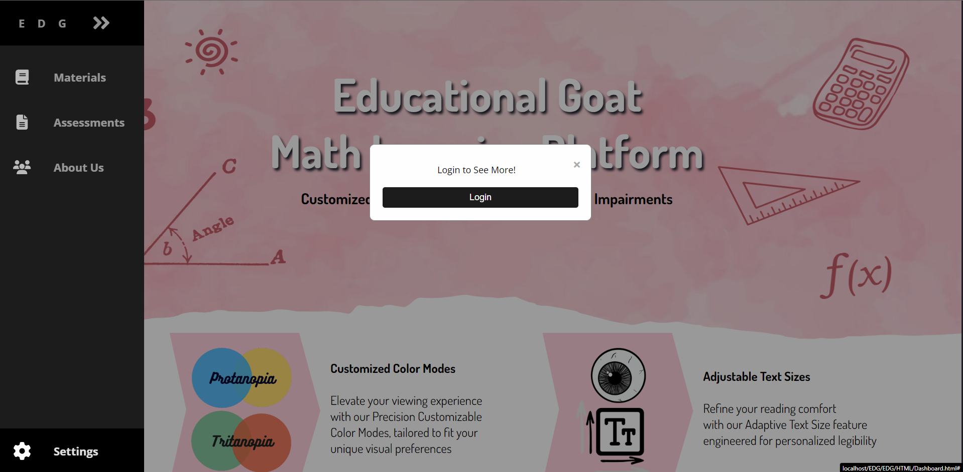

* **Settings**: Adjust user preferences (only available after logging in)

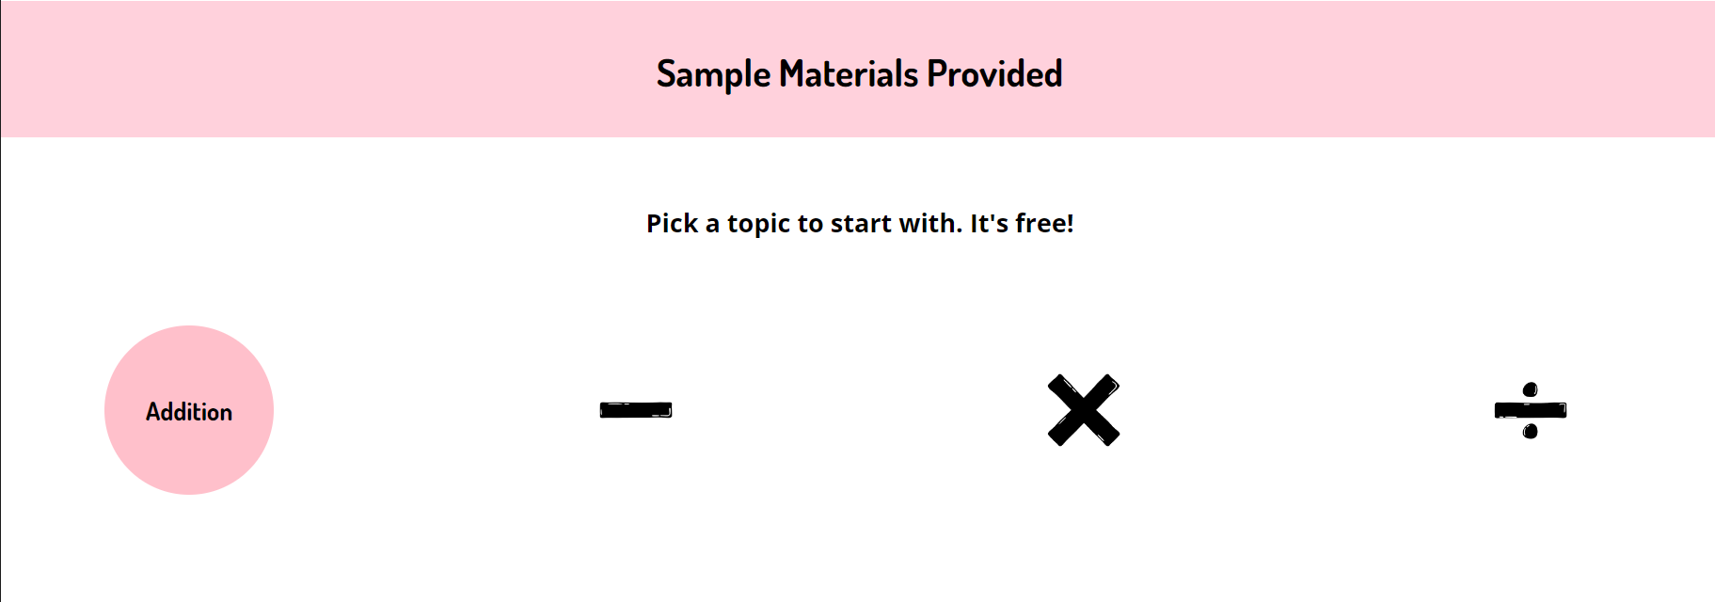

**Sample Materials Provided**:

* **Description**: Displays available learning topics like Addition, Subtraction, Multiplication, and Division.
* **Design**: Sample materials with topics represented by icons
* **Functions**: Allows users to select a topic to start learning.

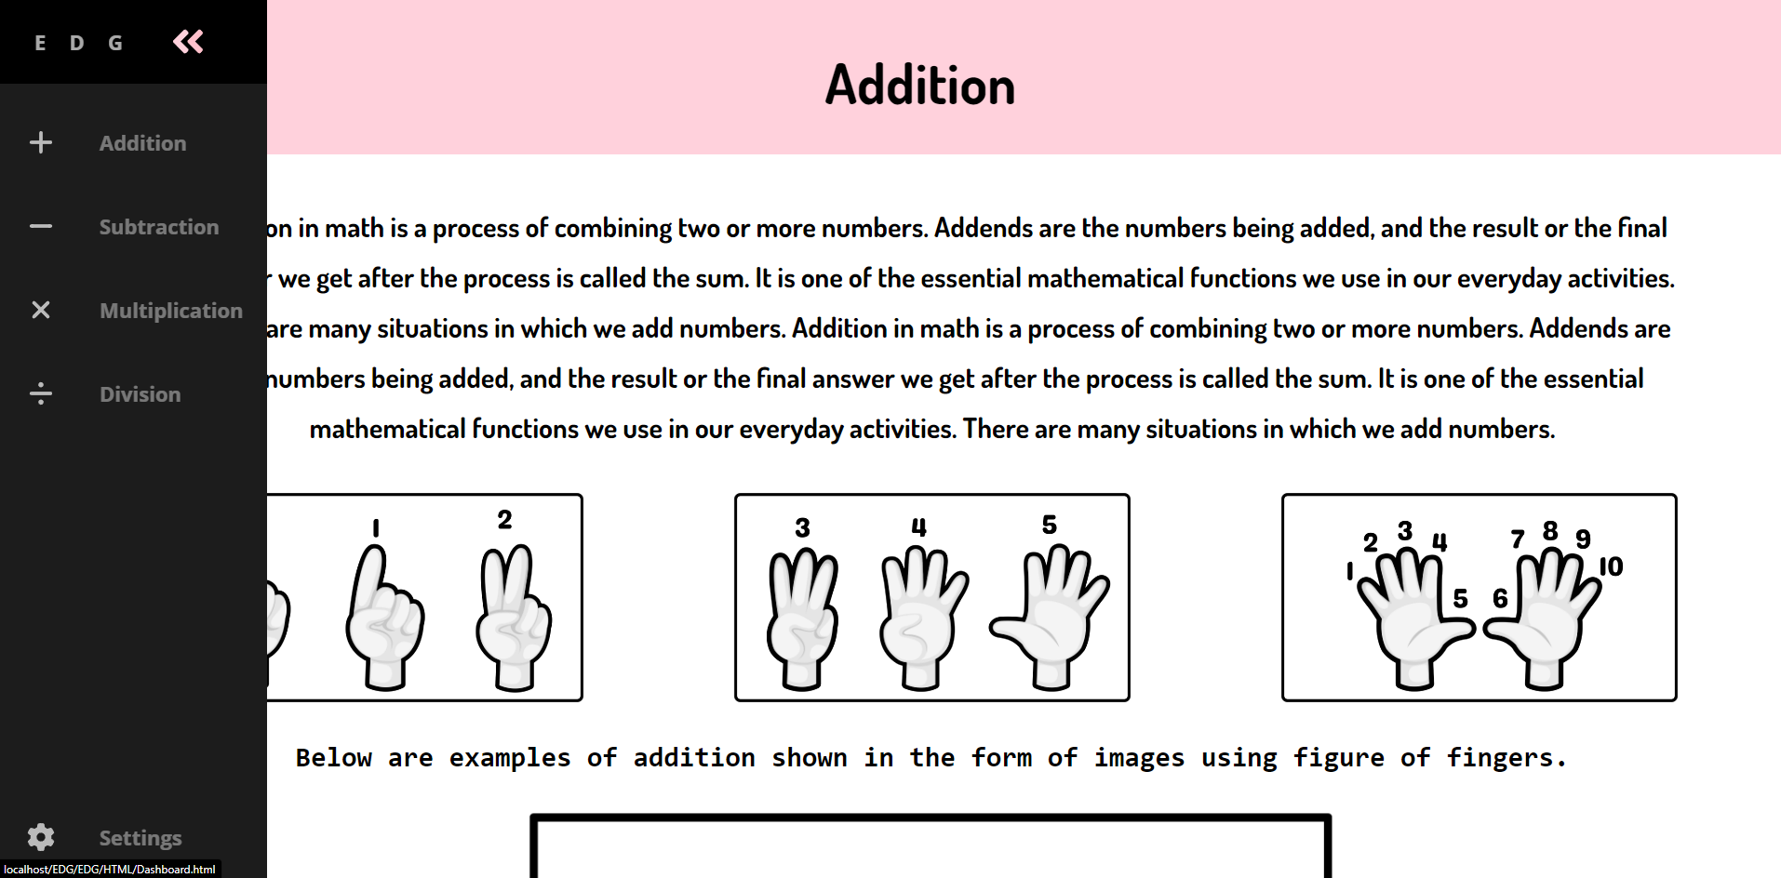

**Sample Materials Overview**

* **Description**: This section provides sample math materials on topics like Addition, Subtraction, Multiplication, and Division.

**User Manual**:

* **Navigation**: Click on any math topic icon (e.g., Addition, Subtraction) to view detailed learning materials.

**Example**:

* **Addition**: This screen explains the concept of addition using text and visual aids such as images of fingers to represent numbers.
* **Further Examples**: Additional examples are provided to help users understand the concept better.

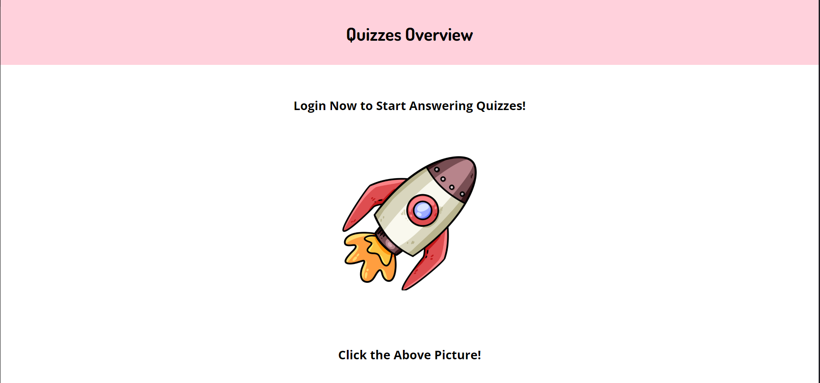

**Quizzes Overview**

* **Description**: This screen prompts users to log in to start answering quizzes.

**User Manual**:

* **Login**: Users must log in to access and answer quizzes.
* **Start Quizzes**: Click on the rocket image to start the quizzes after logging in.

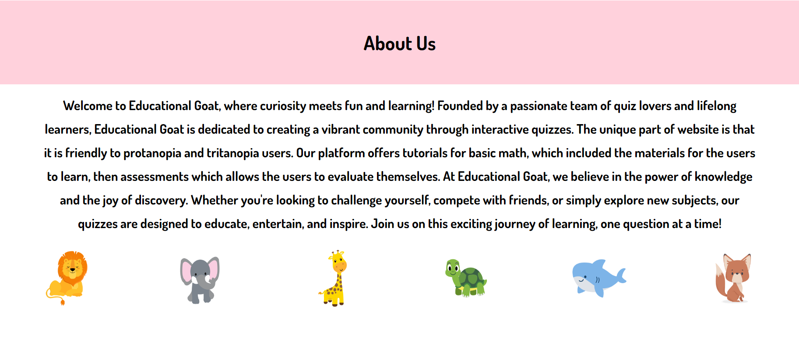

**About Us Overview**

* **Description**: This section provides information about the Educational Goat platform, its mission, and the team behind it.

**User Manual**:

* **Content**: Read through the description to learn about the platform's goals and the team members.
* **Contact Information**: At the bottom of the screen, users can find contact information and social media links.



* **Description**: This is the continuation of About Us Overview

**User Manul**:

* **Content**: Read through the description to learn the platforms creation.

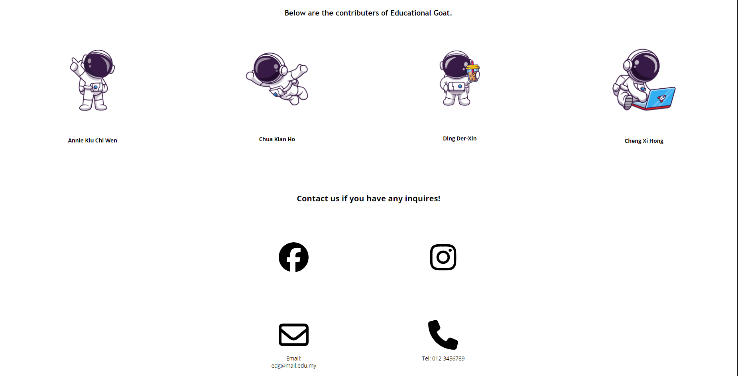

* **Contact Information**: At the bottom of the screen, users can find contact information and social media links.

### 9.1.2 Log In (Creating Profile).

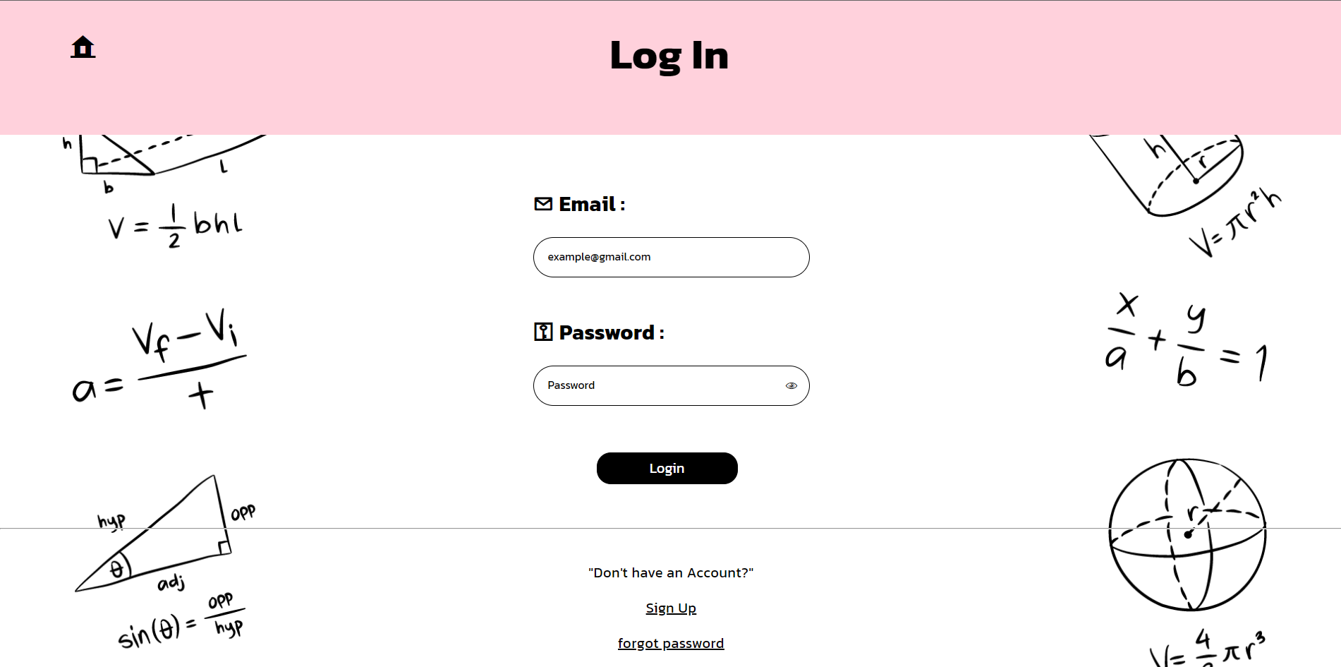

**Log In:**

* **Description:** This page allows existing users to log in by entering their email and password.
* **User Instructions:** Enter the registered email and password, then click the "Login" button. If you don't have an account, click "Sign Up" to create one.

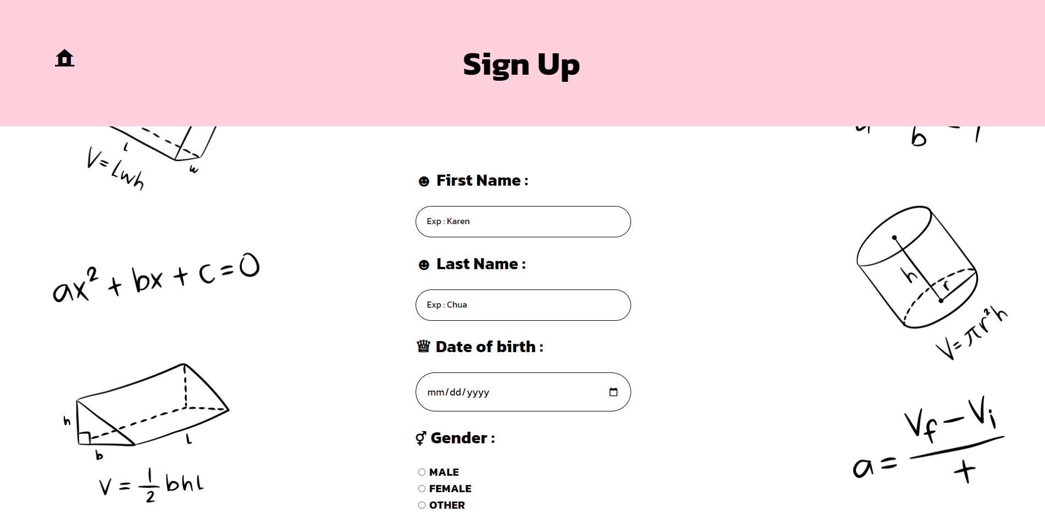

**Sign Up:**

* **Description:** This page allows new users to create an account by providing their personal information.
* **User Instructions:** Fill in the fields such as First Name, Last Name, Date of Birth, Gender, then click the "Sign Up" button.

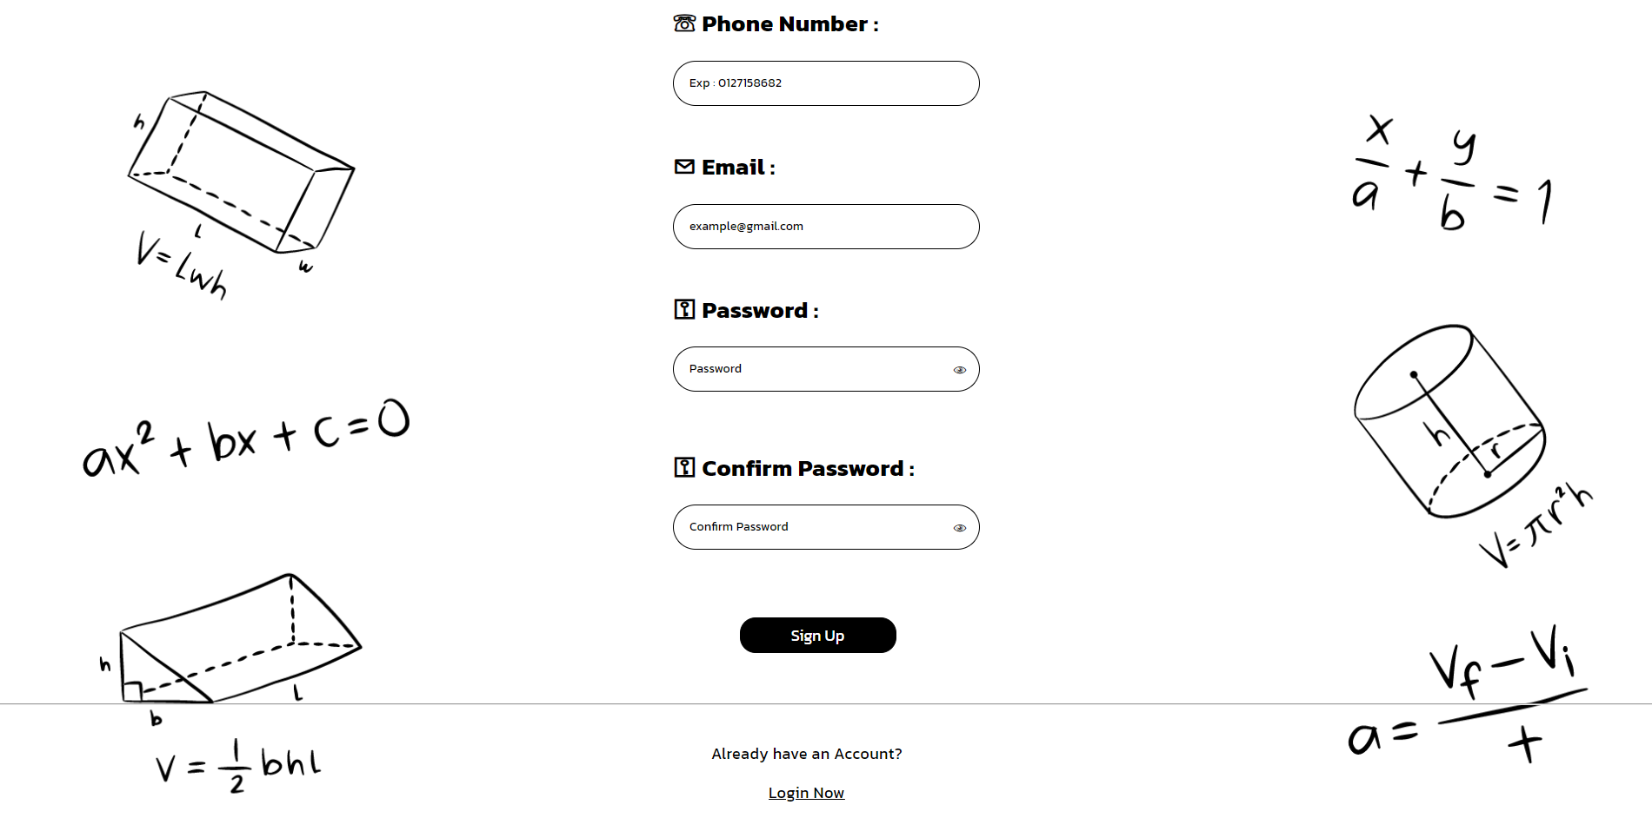

**Sign Up:**

* **User Instructions:** Fill in the fields such Phone Number, Email, Password, and Confirm Password, then click the "Sign Up" button.



**Password Recovery:**

* **Description:** This page helps users recover their forgotten passwords.
* **User Instructions:** Enter the registered email and click "Verify Account" to initiate the password recovery process.

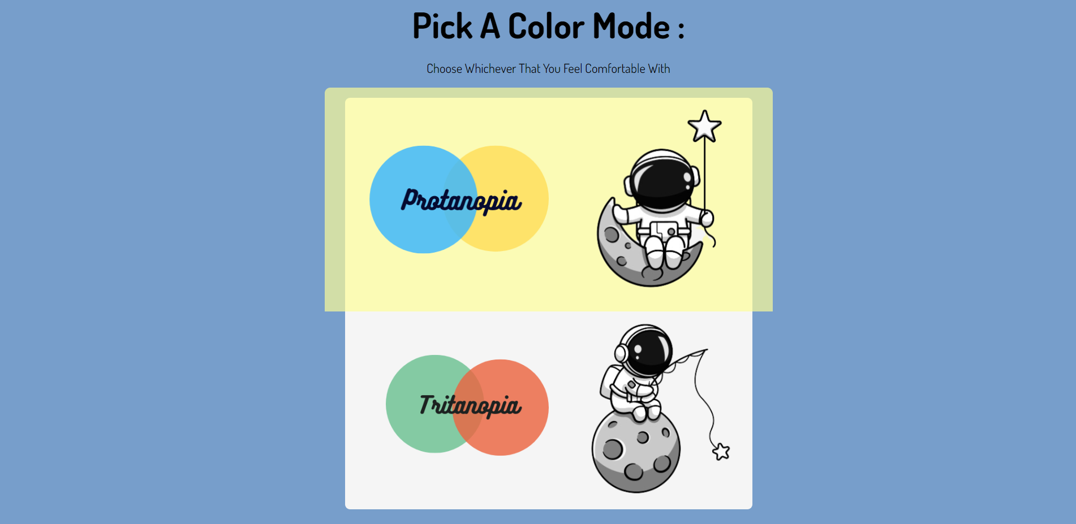

**Color Mode Selection Screen**

* **Description**: This screen allows users to choose their preferred color mode.
* **Screenshot**: Include a screenshot of the color mode selection screen.

**Instructions**:

* Choose between Protanopia and Tritanopia modes by clicking on the respective option.

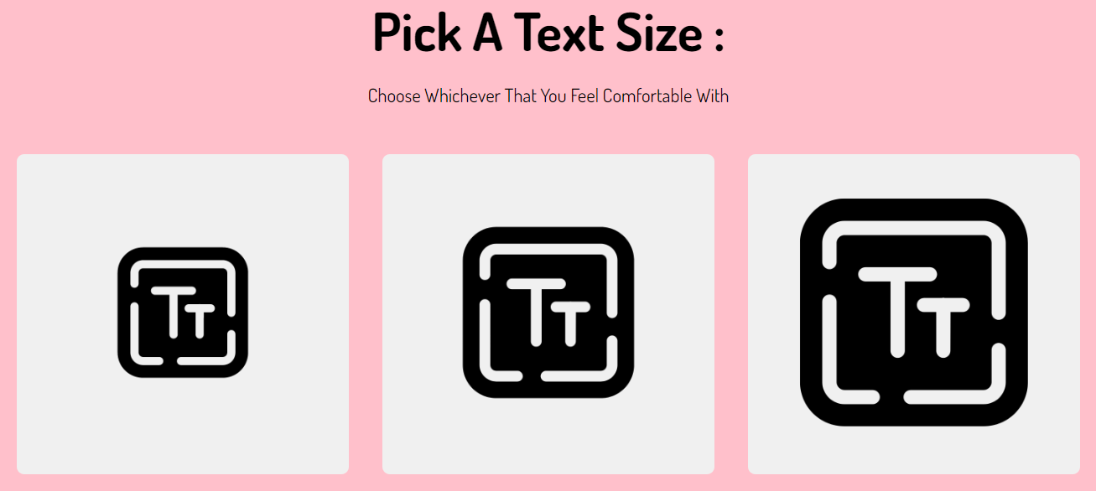

**Text Size Selection Screen**

* **Description**: This screen allows users to choose their preferred text size.
* **Screenshot**:

**Instructions**:

* Choose the text size that you feel comfortable with by clicking on the respective option.

### 9.1.3 Log in User Dashboard



* **Description**: The main interface for logged-in users.

**Components**:



Side Navigation Bar

* **Profile Section**: Displays user profile information and allows editing.
* **Materials Section**: Provides access to learning materials.
* **Quiz Section**: Allows users to take quizzes.
* **Score Section**: Displays quiz results and scores.
* **About Us Section**: Information about the platform and its creators.

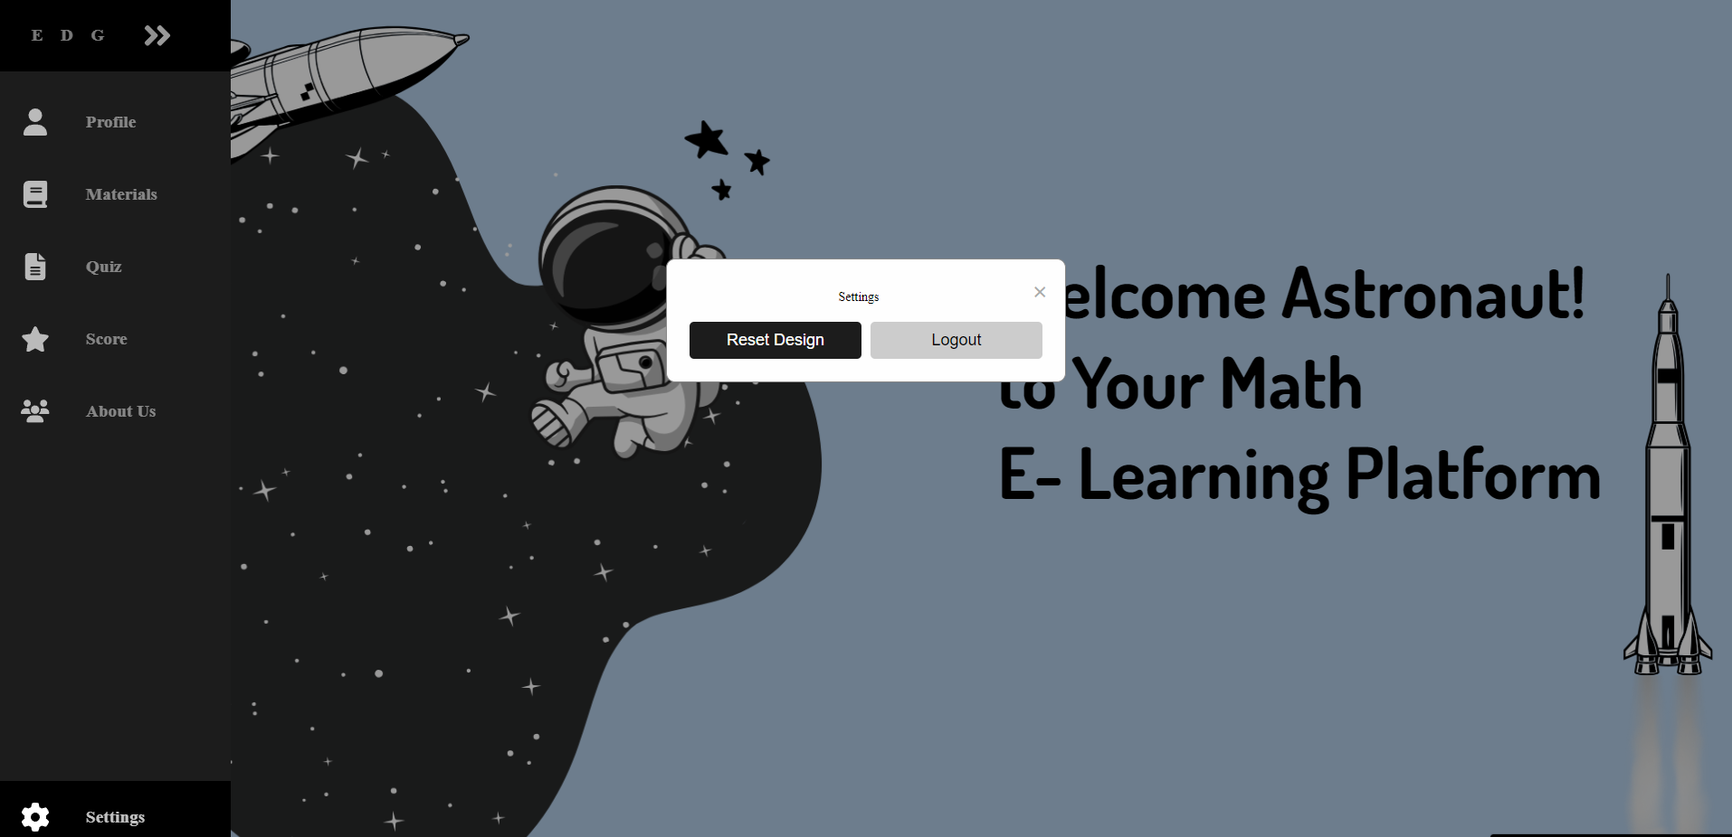

* **Settings**: Options to reset design and log out.

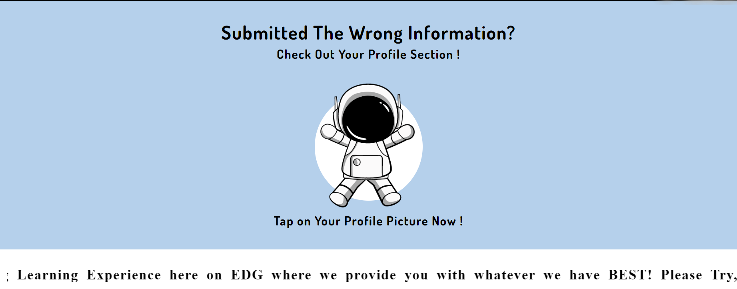

**Profile Section**

* **Description**: Users can view and edit their personal information.
* **User Interaction**: Users can see their profile details and edit them by clicking on the picture button.

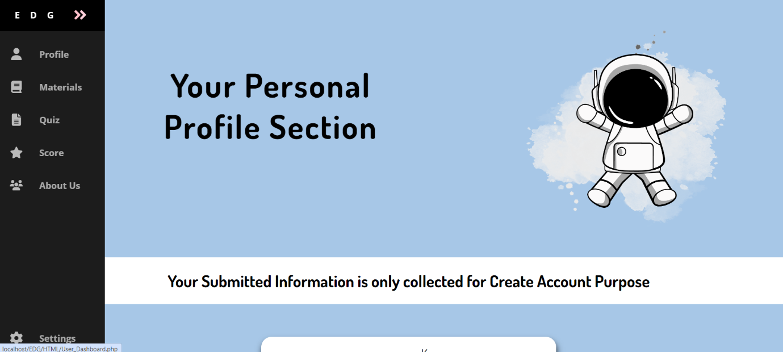

**Edit Profile Screen**

* **Description**: Allows users to update their personal details.

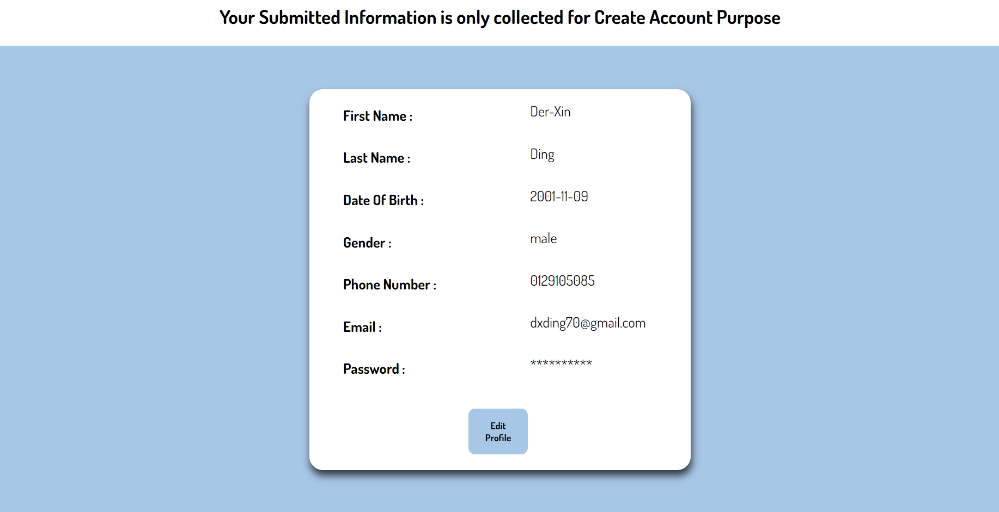

**User Interaction:**

* Users can see their profile details and edit them by clicking on the "Edit Profile" button.

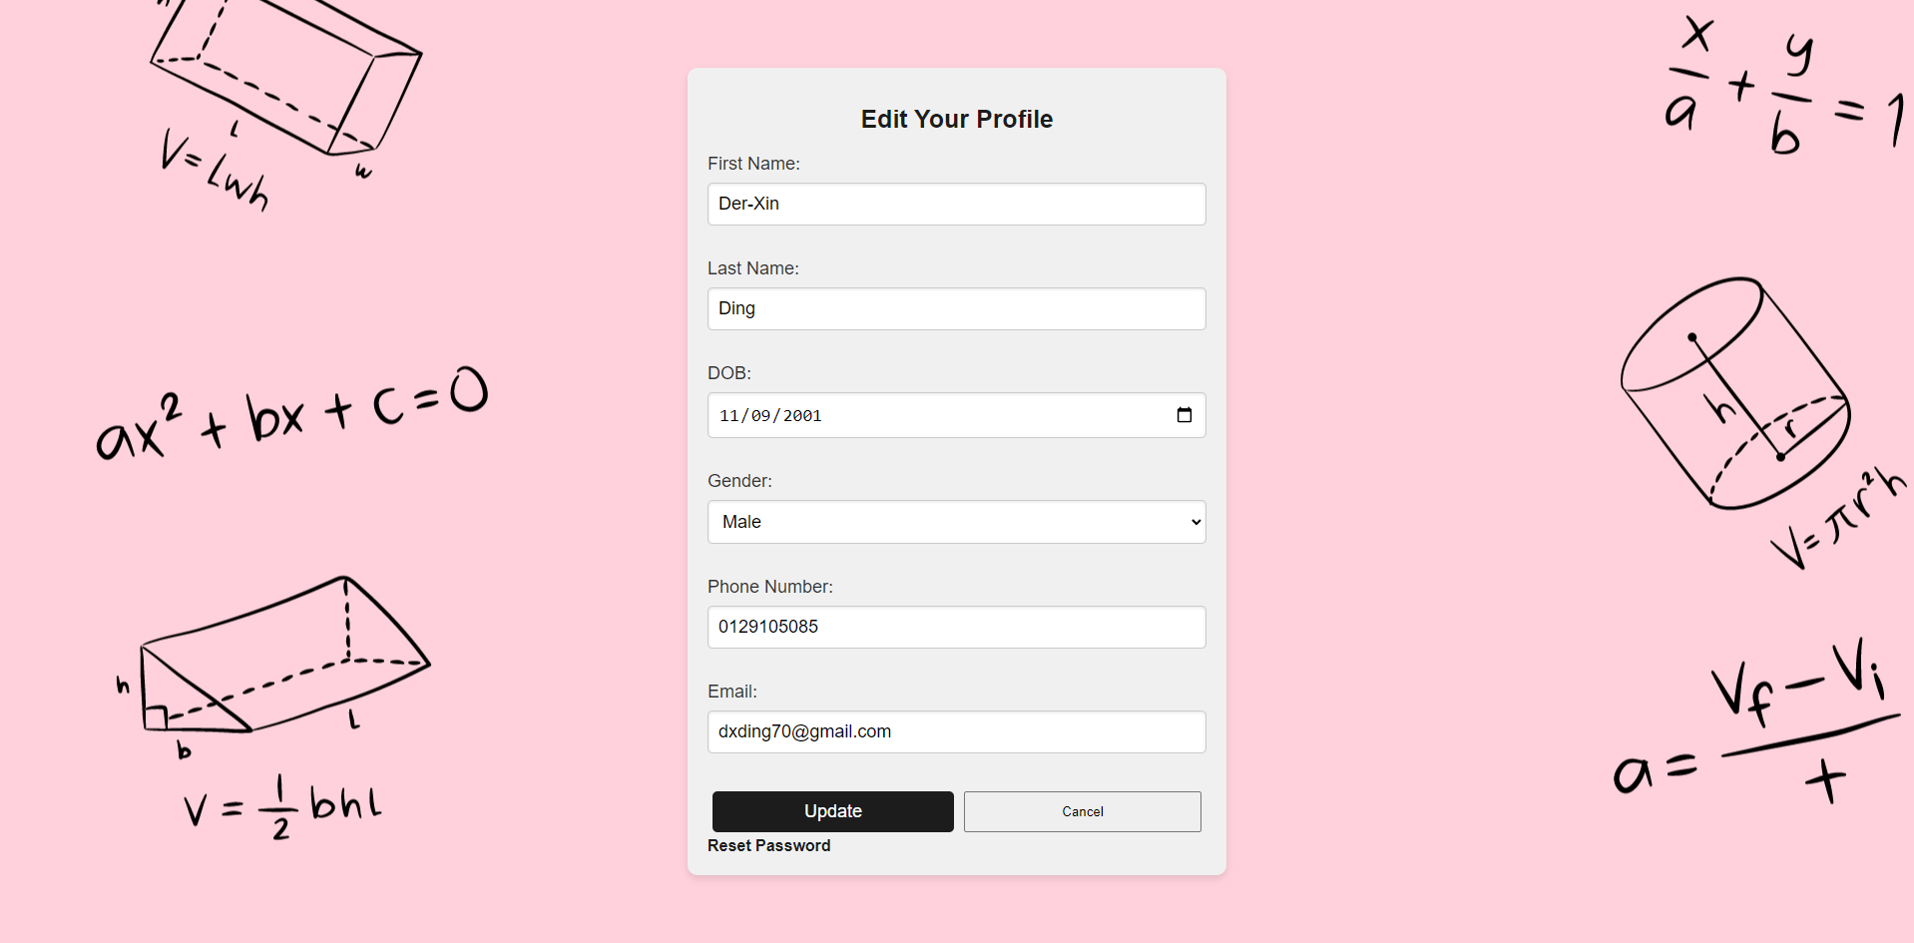

* **User Interaction**: Input fields for updating name, date of birth, gender, phone number, email, and password.

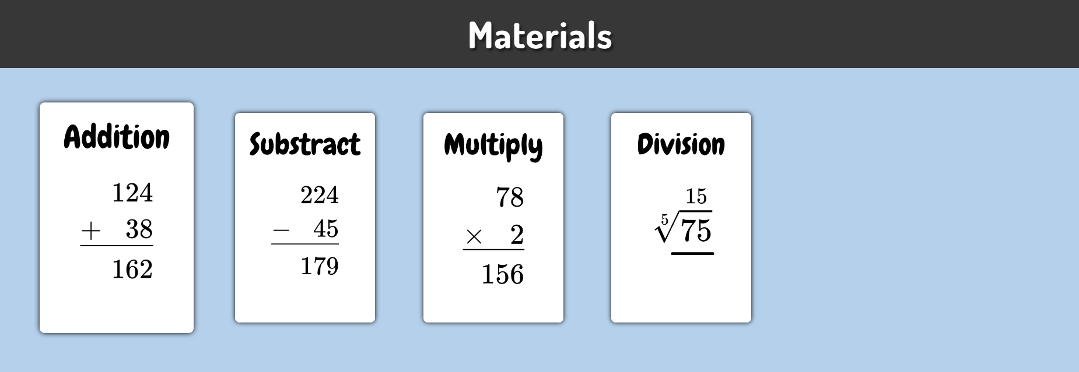

**Materials Section**

* **Description**: Users can choose from various mathematical topics like addition, subtraction, multiplication, and division.
* **User Interaction**: Click on a topic card to start learning.

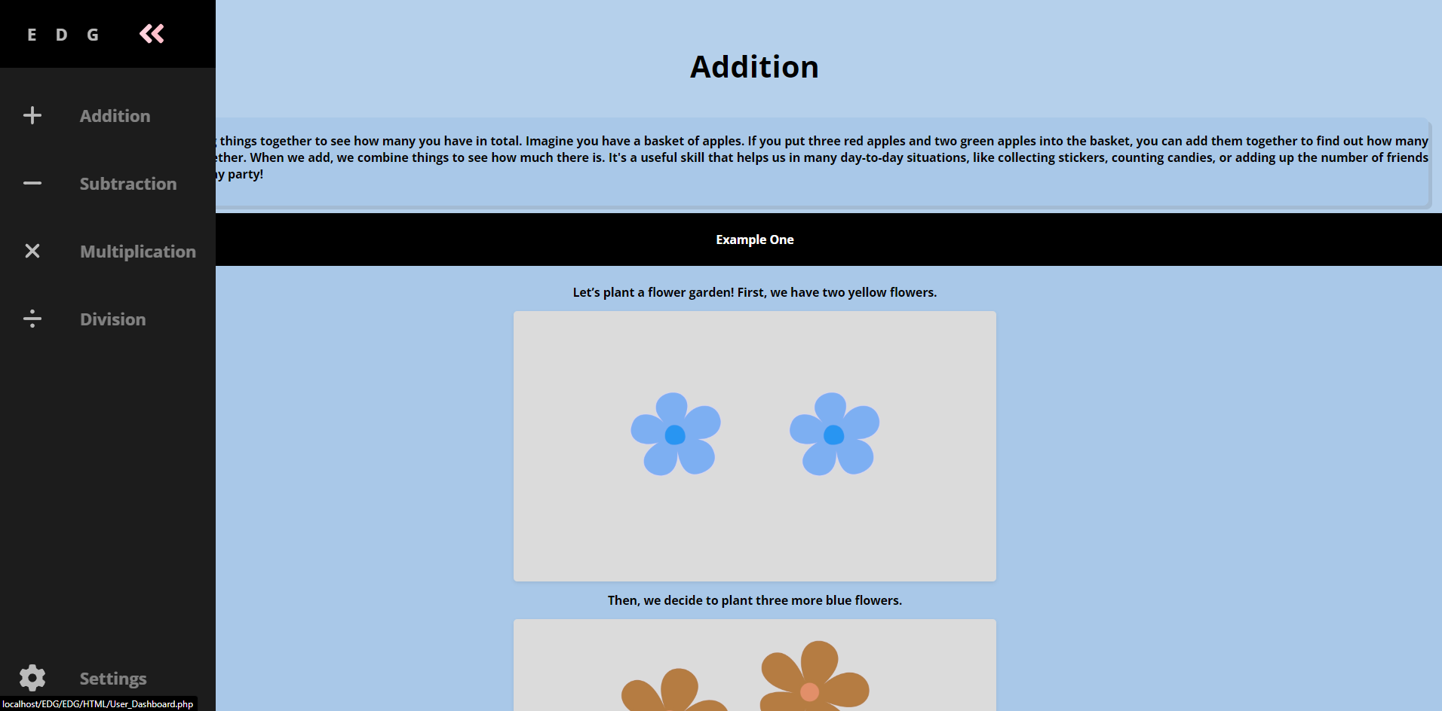

**Addition Module**

* **Description**: Provides instructional content and examples for learning addition.
* **User Interaction**: Users can read through the examples and practice addition problems.

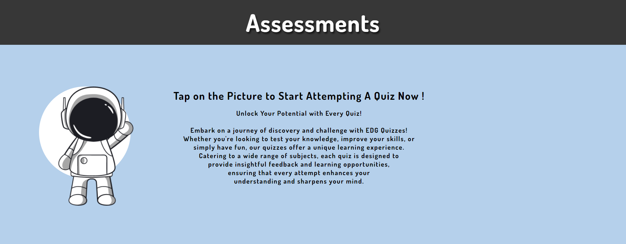

**Quizzes Overview**

* **Description**: Users can start quizzes to test their knowledge on different topics.
* **User Interaction**: Click on the astronaut image to begin a quiz.

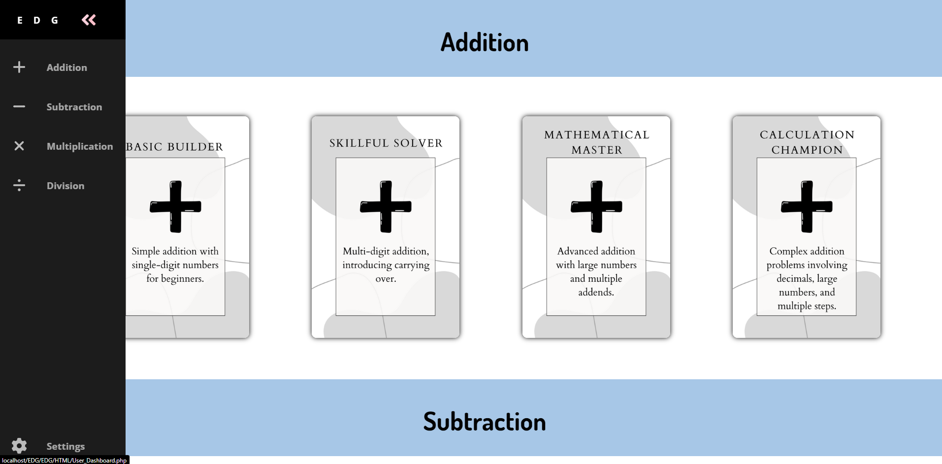

**Materials Section**

* **Description**: Users can choose from various mathematical topics like addition, subtraction, multiplication, and division for the assessment.
* **User Interaction**: Click on assessment level card between (Basic Builder, Skilful Solver, Mathematical Master and Calculation Champion) to start taking questions.

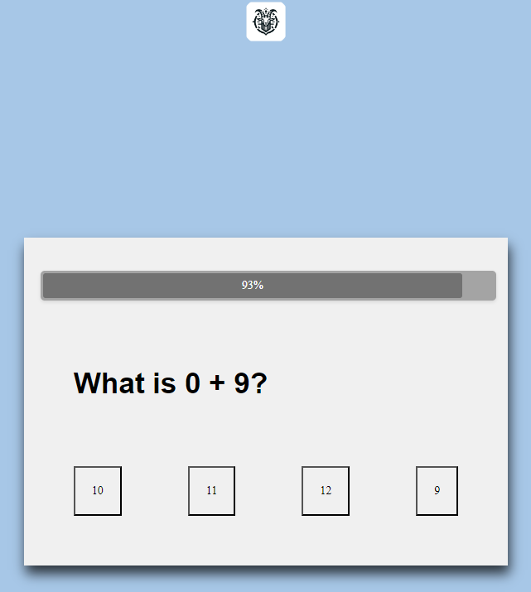

**Quiz Interface**

* **Description**: Interactive quiz interface where users can answer multiple-choice questions.
* **User Interaction**: Select an answer and proceed to the next question.

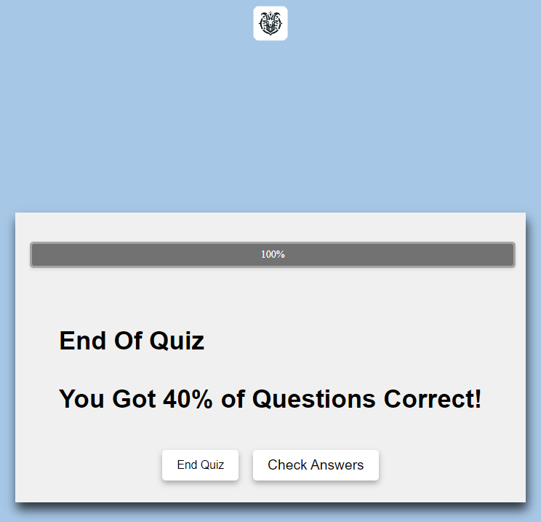

**Quiz Results**

* **Description**: Displays the user's performance at the end of the quiz.
* **User Interaction**: View the number of correct answers and overall percentage. Users can choose to check their answers or end the quiz.

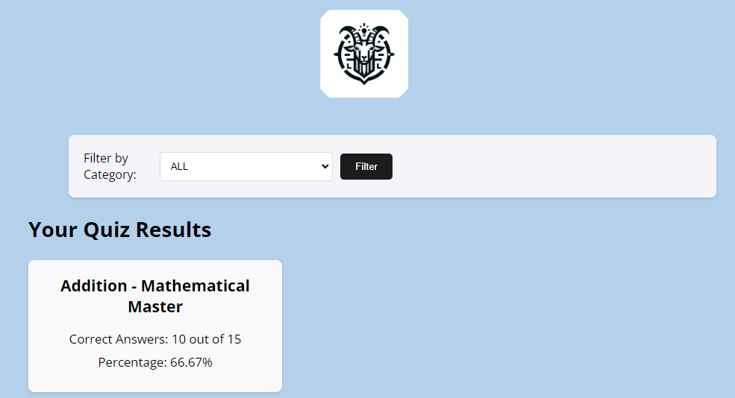

Score

* Description: Display the user’s performance at the Score Section of the quiz that the user taken.
* User Interaction:

Users can view which quiz they have taken and type of quiz by using the filter function.



**About Us Section**

* **Description**: Provides information about the Educational Goat platform and its contributors.



**User Interaction**:

* Users can read about the mission and vision of the platform and get to know the team behind it.

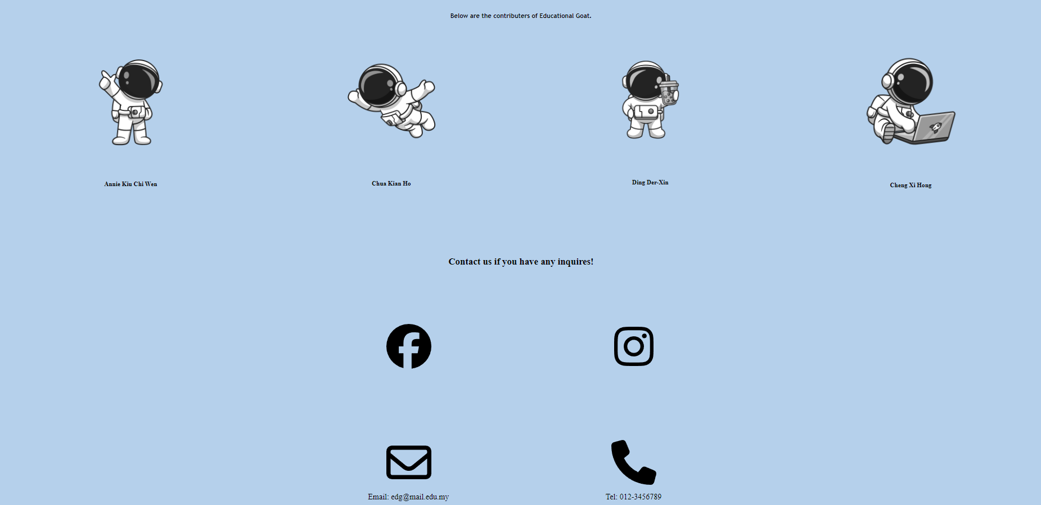

* Users can contact the development team and see who’s are responsible for EDG.

## 10.2 Admin

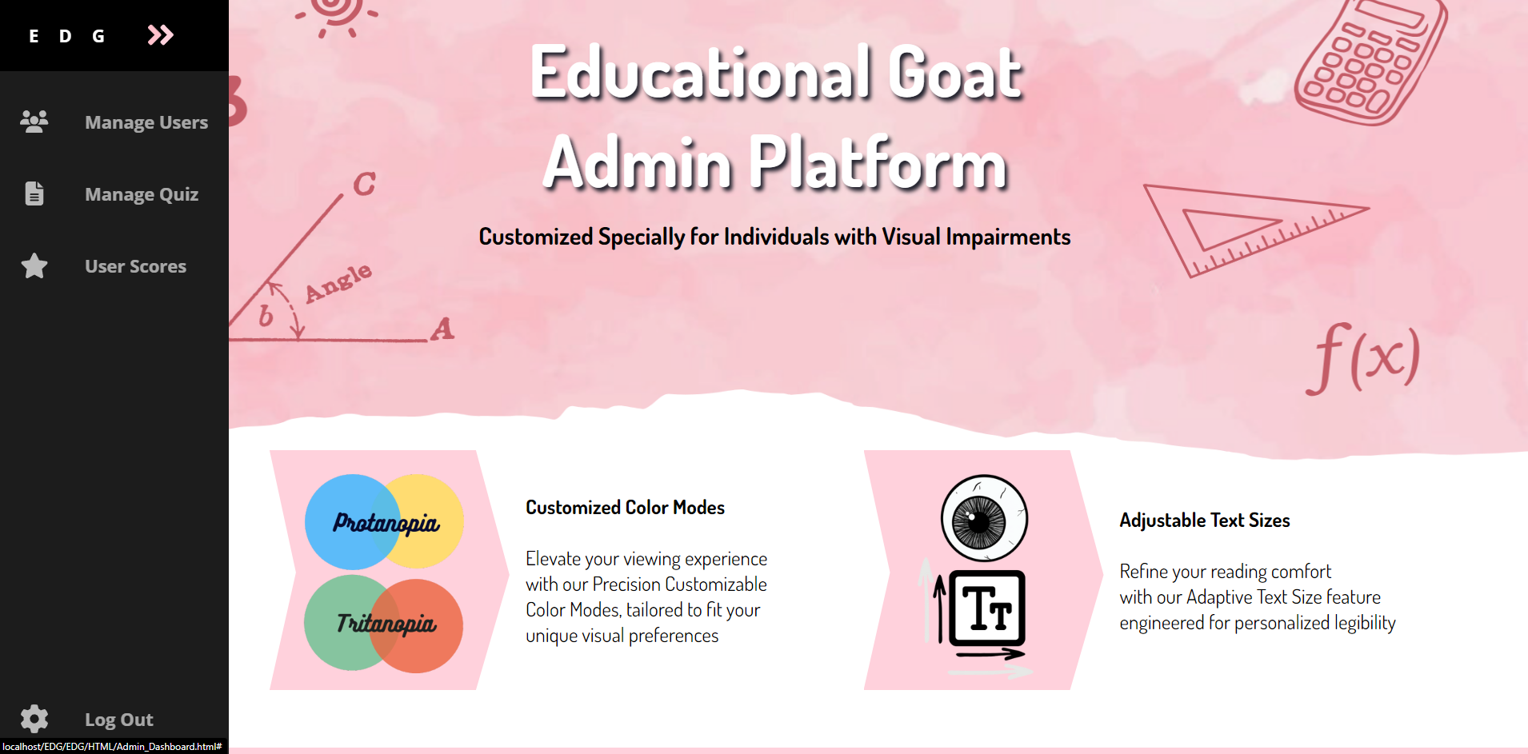

**Admin Dashboard**

**Description:** The Admin Dashboard is the central hub for managing the Educational Goat platform. It provides quick access to user management, quiz management, and user scores.

**Interactions:**

* **Manage Users:** Navigate to the user management page to view, edit, or delete user information.
* **Manage Quiz:** Navigate to the quiz management page to add, edit, or delete quiz questions.
* **User Scores:** View the scores and performance of users on various quizzes.
* **Log Out:** To let the admin log out.

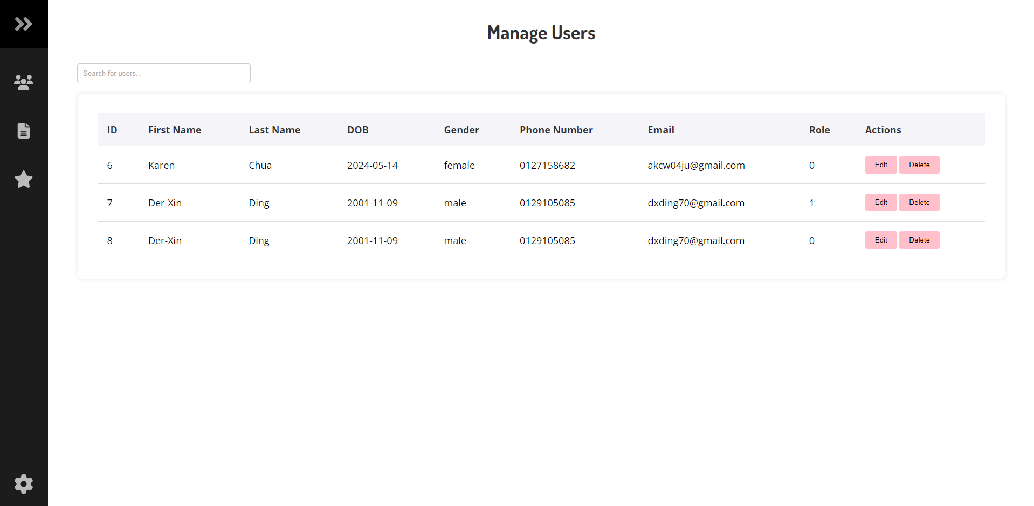

**Description:** The Manage Users screen allows the admin to view a list of all users, with options to edit or delete user details.

**Interactions:**

* **Search Bar:** Filter users by entering keywords related to their names or emails.
* **Edit Button:** Click to open the Edit User form for updating user details.
* **Delete Button:** Click to remove a user from the system.

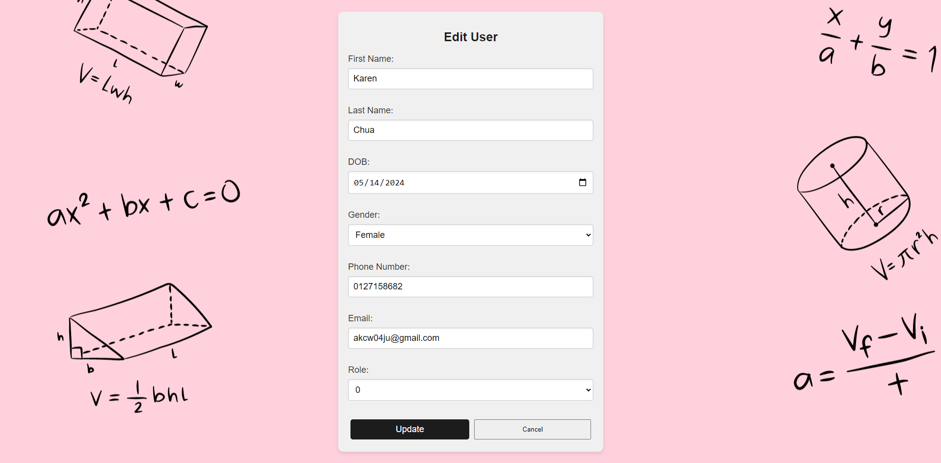

**Description:** The Edit User form allows the admin to update user information such as name, date of birth, gender, phone number, email, and role.

**Interactions:**

* **Update Button:** Save the changes made to the user's details.
* **Cancel Button:** Discard any changes and return to the previous screen.

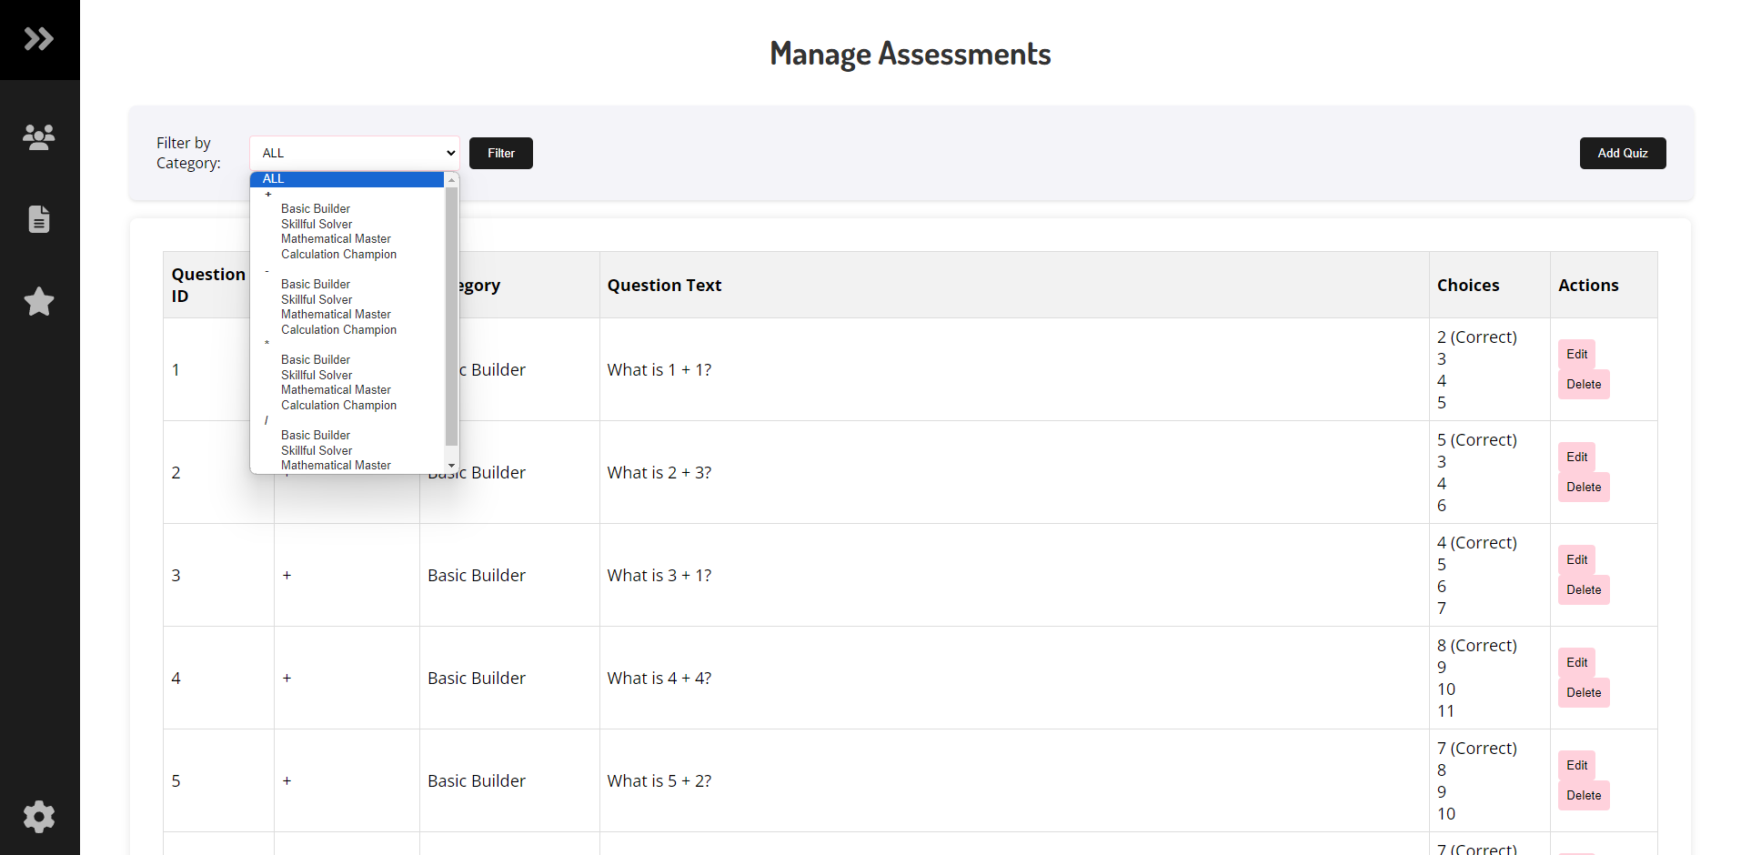

**Manage Quizzes:**

**Description:** The Manage Quizzes screen enables the admin to view, filter, and manage quiz questions. Admins can add new quizzes or edit existing ones.

**Admin Interactions:**

* **Filter by Category:** Select a category to filter the list of quiz questions.
* **Edit Button:** Open the Edit Assessment form to modify an existing question.
* **Delete Button:** Remove a question from the quiz.
* **Add Quiz Button:** Open the Add New Assessment form to create a new quiz question.

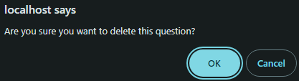

* When admin wants to delete a question will need confirmation either (OK or Cancel).

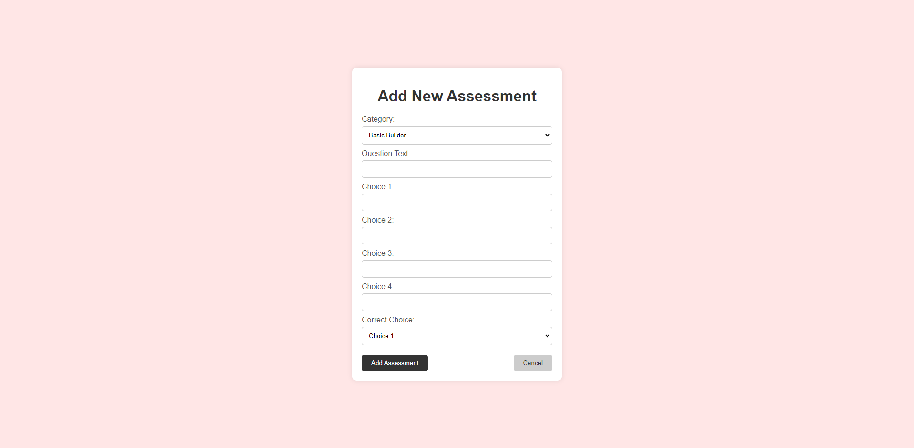

**Description:** The Add New Assessment form allows the admin to create a new quiz question by specifying the category, question text, answer choices, and the correct answer.

**Interactions:**

* **Category Dropdown:** Select the category for the new question.
* **Question Text Field:** Enter the quiz question.
* **Choice Fields:** Provide up to four answer choices.
* **Correct Choice Dropdown:** Select the correct answer from the provided choices.
* **Add Assessment Button:** Save the new quiz question.
* **Cancel Button:** Discard the new quiz question and return to the previous screen.

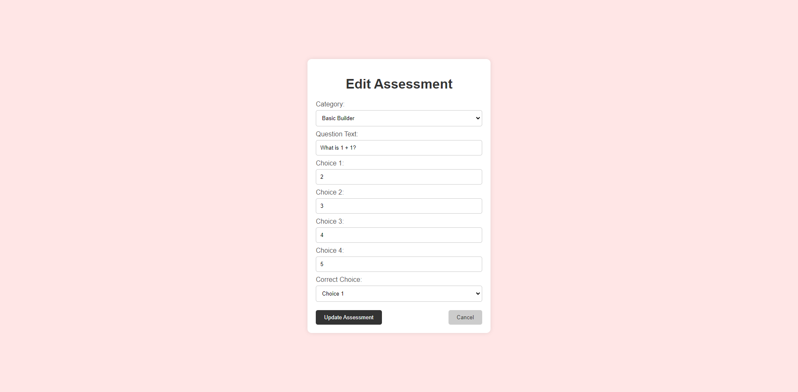

**Description:** The Edit Assessment form allows the admin to update an existing quiz question, including the category, question text, answer choices, and the correct answer.

**Admin Interactions**

* **Category Dropdown:** Select a new category for the question if necessary.
* **Question Text Field:** Update the quiz question.
* **Choice Fields:** Modify the answer choices.
* **Correct Choice Dropdown:** Change the correct answer.
* **Update Assessment Button:** Save the updated quiz question.
* **Cancel Button:** Discard the changes and return to the previous screen.

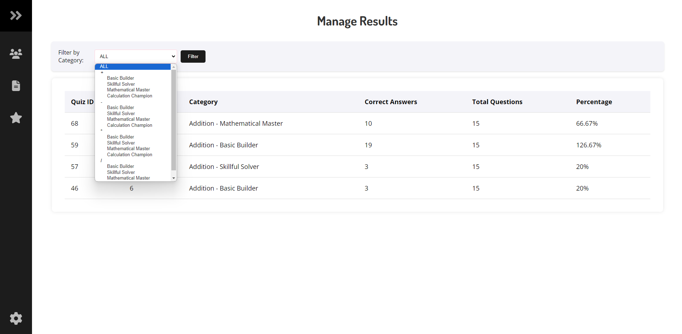

**Description:** The Manage Results screen displays the performance of users on various quizzes, with options to filter by category and view detailed results.

**Interactions:**

* **Filter by Category:** Select a category to filter the list of quiz results.

# 11.0 Test Plan

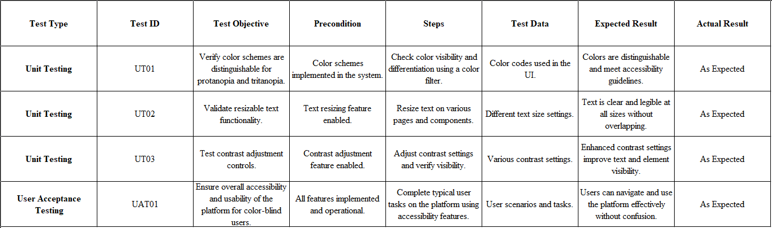

## 11.1 Unit Testing

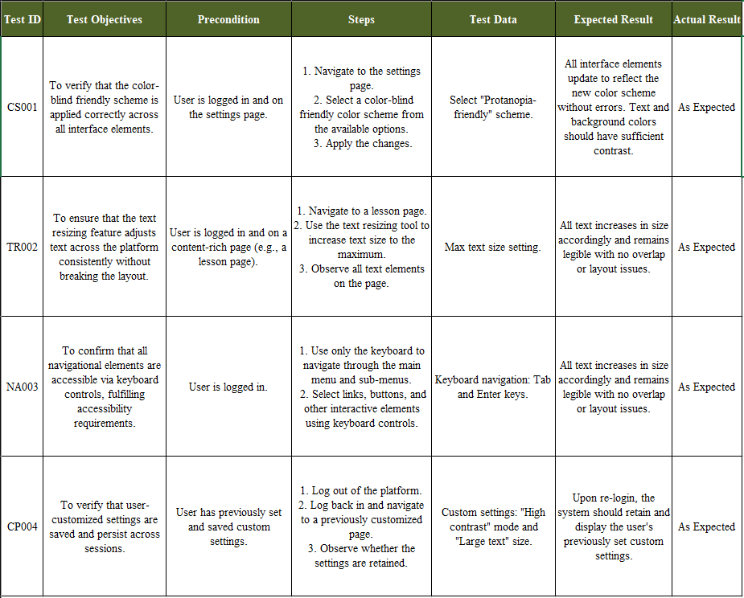

## 11.2 User Acceptance Testing

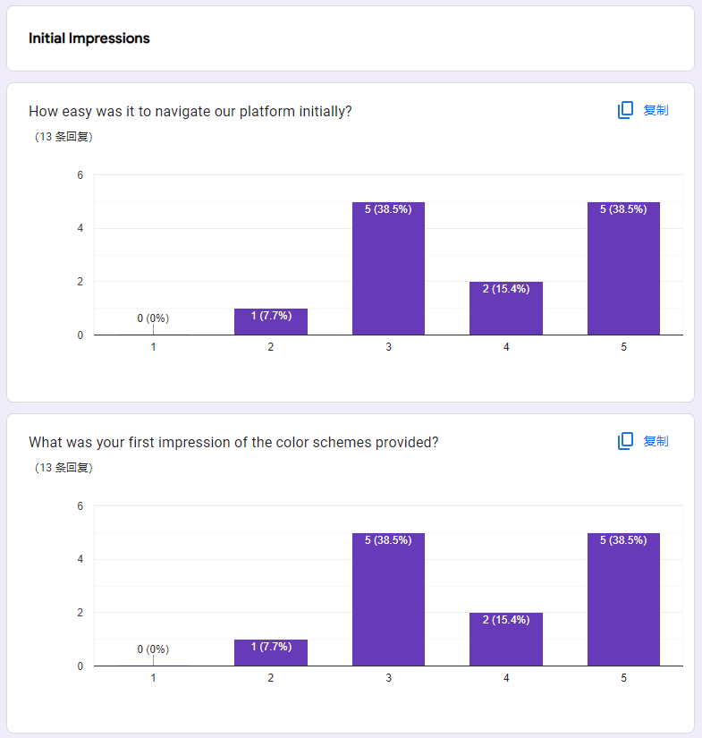

The survey results regarding the initial impressions of a platform reveal mixed feedback on both ease of navigation and the color schemes provided. For navigation, the responses are sharply divided, with 38.5% of users finding it very easy and an equal percentage finding it very challenging, suggesting significant variability in user experience. Similarly, impressions of the color schemes also show polarization, with 38.5% rating them positively and the same percentage having a negative view, indicating that while some users are satisfied, others may struggle or find the design choices suboptimal. Intermediate responses are minimal for both aspects, highlighting a strong divergence in user experiences and perceptions.

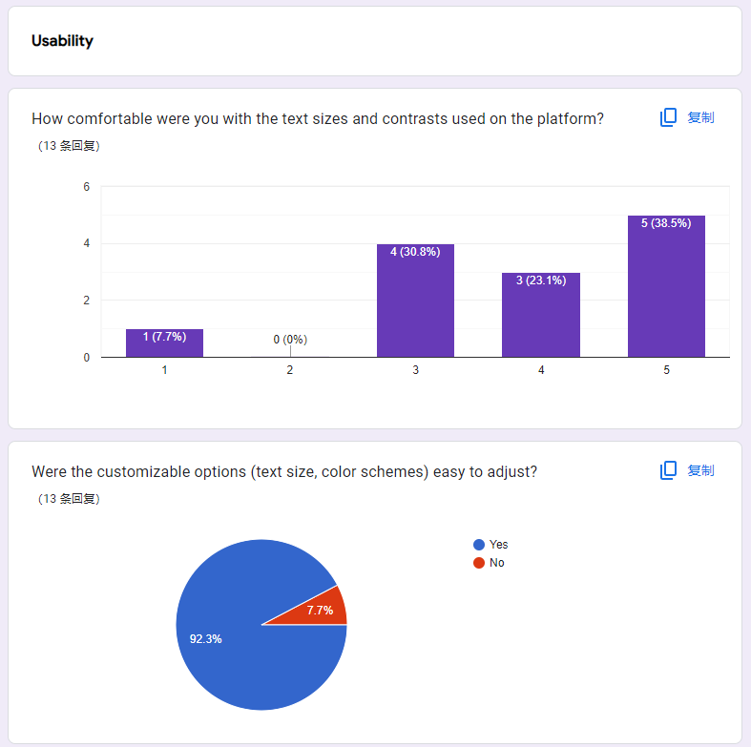

The survey results illustrated in the image highlight user feedback on the usability aspects of a platform, specifically focusing on the comfort with text sizes and contrasts and the ease of customizing options like text size and colour schemes. A majority of the respondents felt comfortable with the text sizes and contrasts provided on the platform, with 38.5% expressing the highest level of comfort and another 30.8% also feeling quite comfortable. Moderately comfortable responses were given by 23.1% of users, while a small minority of 7.7% indicated significant discomfort. Additionally, the vast majority (92.3%) found the customizable options for text and colour schemes easy to adjust. These results suggest that the platform generally offers a user-friendly experience in terms of readability and customization.

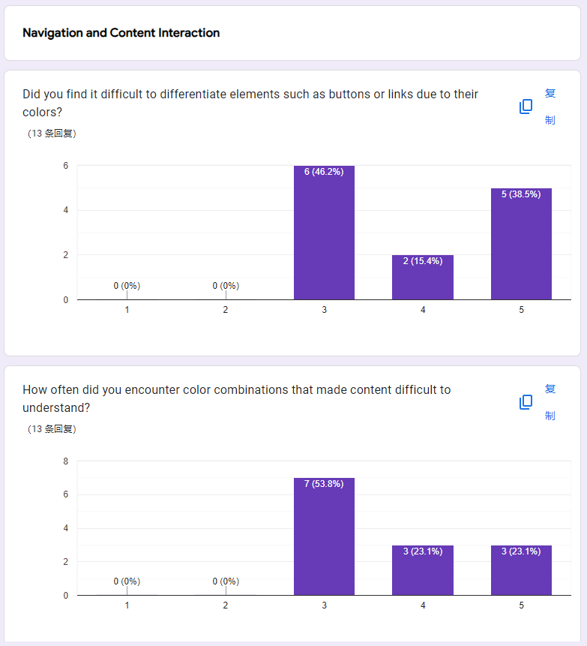

The survey results regarding navigation and content interaction on a platform reveal significant challenges related to colour differentiation and confusing colour combinations. Participants rated the difficulty of distinguishing elements like buttons and links due to their colours, with no respondents finding it easy (scores 1 and 2), a majority expressing moderate difficulty (46.2% scored it 3), and substantial numbers finding it quite difficult (15.4% scored it 4) or extremely difficult (38.5% scored it 5). Additionally, when asked about the frequency of encountering problematic colour combinations that hindered content understanding, the majority reported frequently facing such issues, with 53.8% indicating a high frequency (score 4), and 23.1% experiencing this very frequently (score 5). This data suggests a critical need for improvements in the platform’s colour scheme to enhance usability and accessibility.

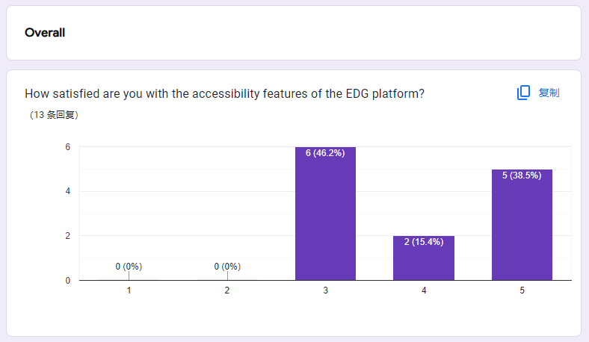

The survey results depicted in the image show that users have a diverse range of satisfaction levels with the accessibility features of the EDG platform. Out of 13 respondents, a plurality rated their satisfaction as neutral (3) at 46.2%, indicating moderate satisfaction. However, the remaining responses indicate more positive impressions, with 15.4% feeling quite satisfied (4) and 38.5% very satisfied (5). Notably, there are no respondents who rated their satisfaction as low (1 or 2), suggesting that while improvements could be made, the overall reception of the accessibility features on the platform is fairly positive.

# 12.0 Significant Source Codes

Organized Code Structure

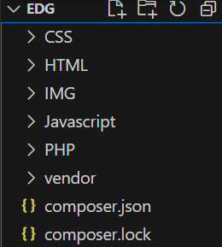

Each different folder keeps the files according to their code type.

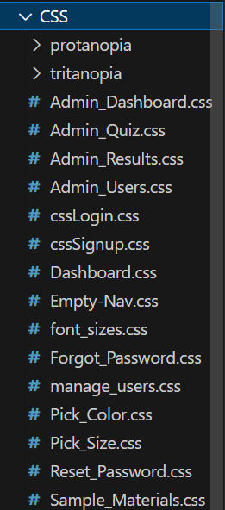

Shared CSS files is placed directly into the CSS folder

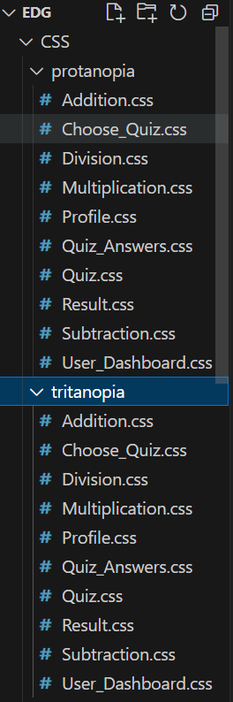

CSS files that are used to be able to switch colour modes are placed separately into two different folders, protanopia and tritanopia.

## 12.1 Choose Colour Mode Function

This function allows users to select their preferred color mode (Protanopia or Tritanopia) on the Educational Goat platform. The selection adjusts the interface to accommodate users with specific types of color blindness.

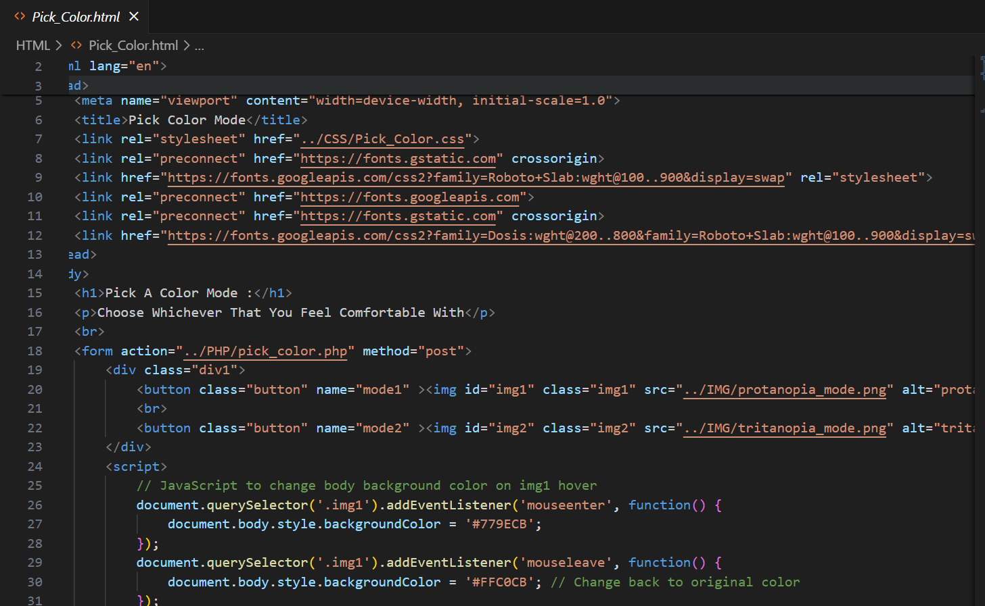

Figure12.1.1

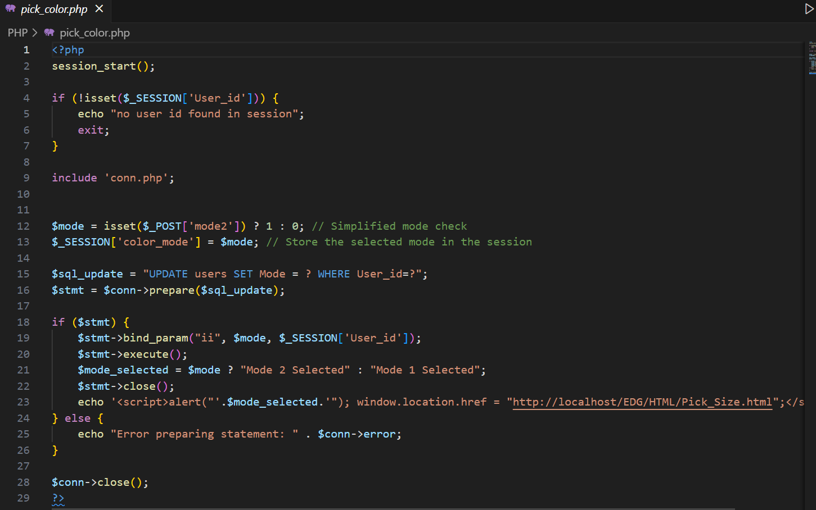

Figure12.1.2

The script in Figure 12.1.2 is the backend function file connected to the above Figure 12.1.1 html file, it includes a database connection file and retrieves a user-selected mode from a POST request, storing this preference in the session. It then prepares and executes an SQL statement to update the user's mode preference in the database. If successful, it alerts the user of the mode selected and redirects them to another page. If there's an issue with preparing the SQL statement, it reports an error.

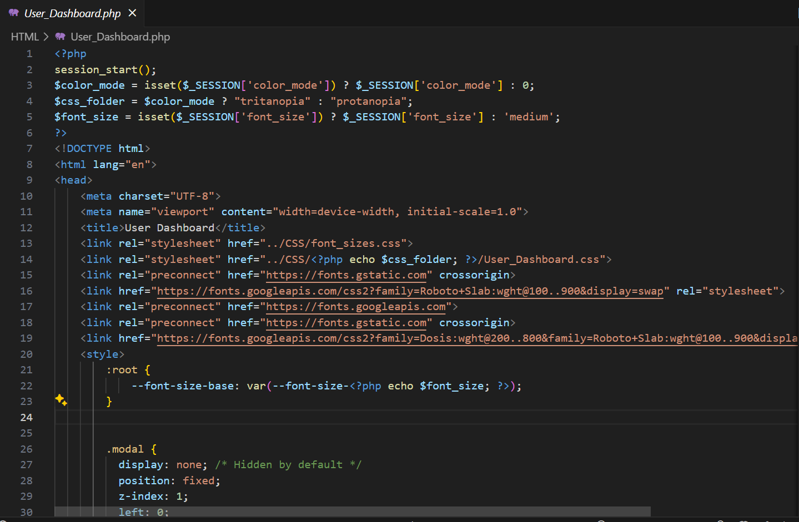

Figure 12.1.3

Here is an example of the implemented colour mode changes for User Dashboard page. In Figure 12.1.3, the PHP code implemented into the link for style sheets works to get session data saved into the session. If colour mode is 1, the variable “css_folder” stands for the text “tritanopia”. In contrast, if the colour mode is 0, the variable “css_folder” stands for text “protanopia”. This way the correct CSS file will be taken from the wanted CSS folder.

By doing so, after users pick their preferred colour choice in the HTML file, the colour of the interface will switch accordingly.

## 12.2 Choose Text Size Function

Like the Colour mode function, this function where user can choose their preferred text size for their interface works likewise.

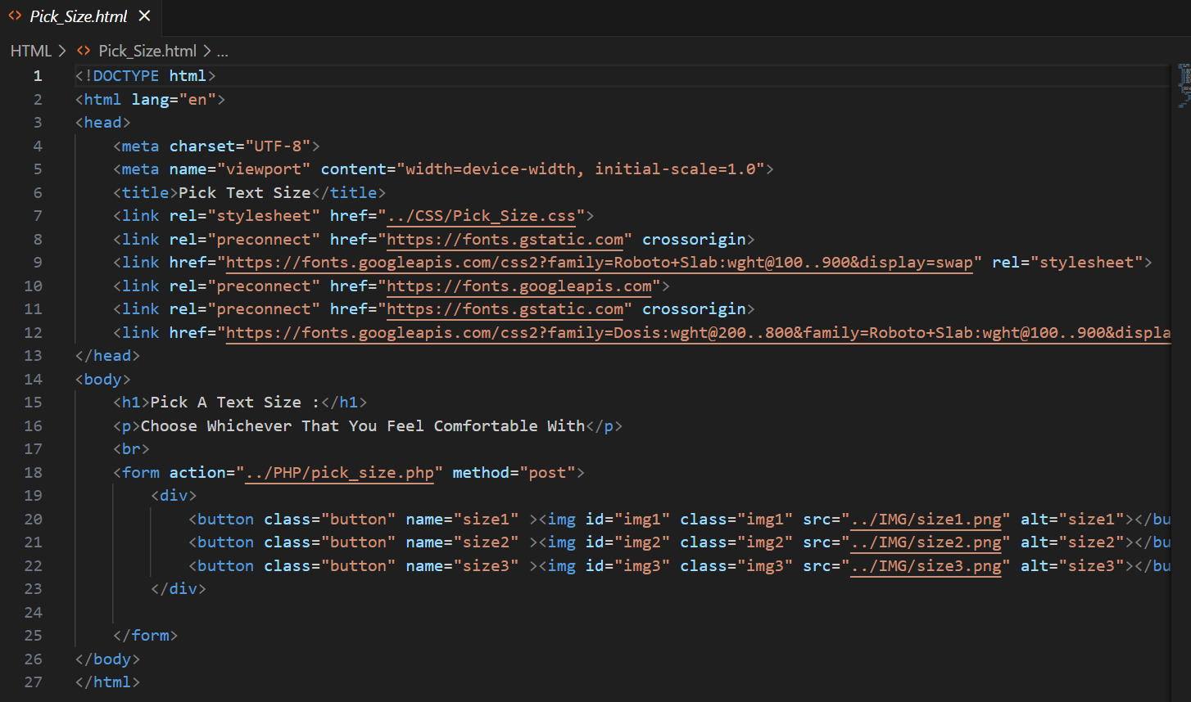

Figure12.2.1

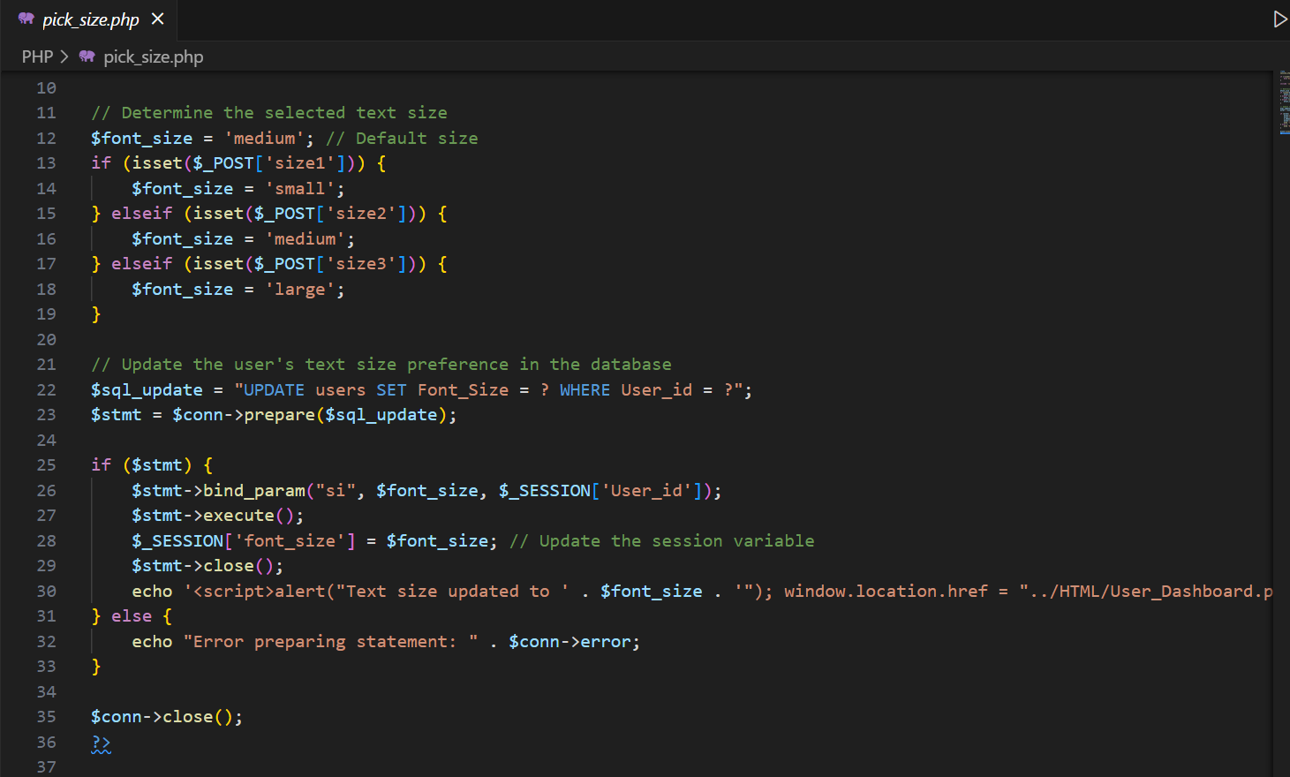

Figure12.2.2

This external PHP file stores the functionality of Figure 12.2.2 HTML file, it starts by ensuring a session is active and the user is identified, then proceeds to fetch the user's desired text size from a form submission. It updates this preference in the database and reflects the change in the session data. The script ensures secure database interactions using prepared statements and provides immediate feedback to the user about the status of their preference update, including a redirection to a dashboard page.



Figure12.2.3

Here is a somewhat similar example of the implemented Text Size functionality using the User Dashboard page. In Figure 12.2.3, the PHP code implemented into the link for style sheets works to get session data saved into the session during Figure 12.2.2. In the internal CSS code, root font size uses the font size saved into the session data. The font size is differentiated into three forms, specifically small, medium and large. Here are the details of the text sizes shown in Figure 12.2.4.

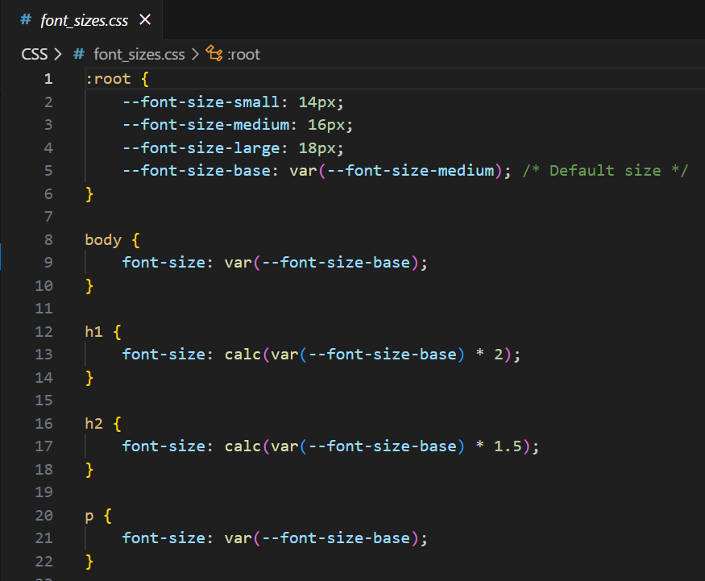

Figure12.2.4

The default size is 16px, small is14px and large is 18px. To ensure that all text sizes are adjustable by users, a minor tweak in our external CSS is needed. For headers that should be larger than the default given size medium like in Figure12.2.4, take an example 60px, 60 must be divided by 16 to get the supposed enlarged value. As shown below in Figure 12.2.5.

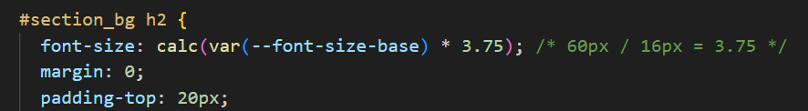

Figure12.2.5

## 12.3 Forgot Password Function

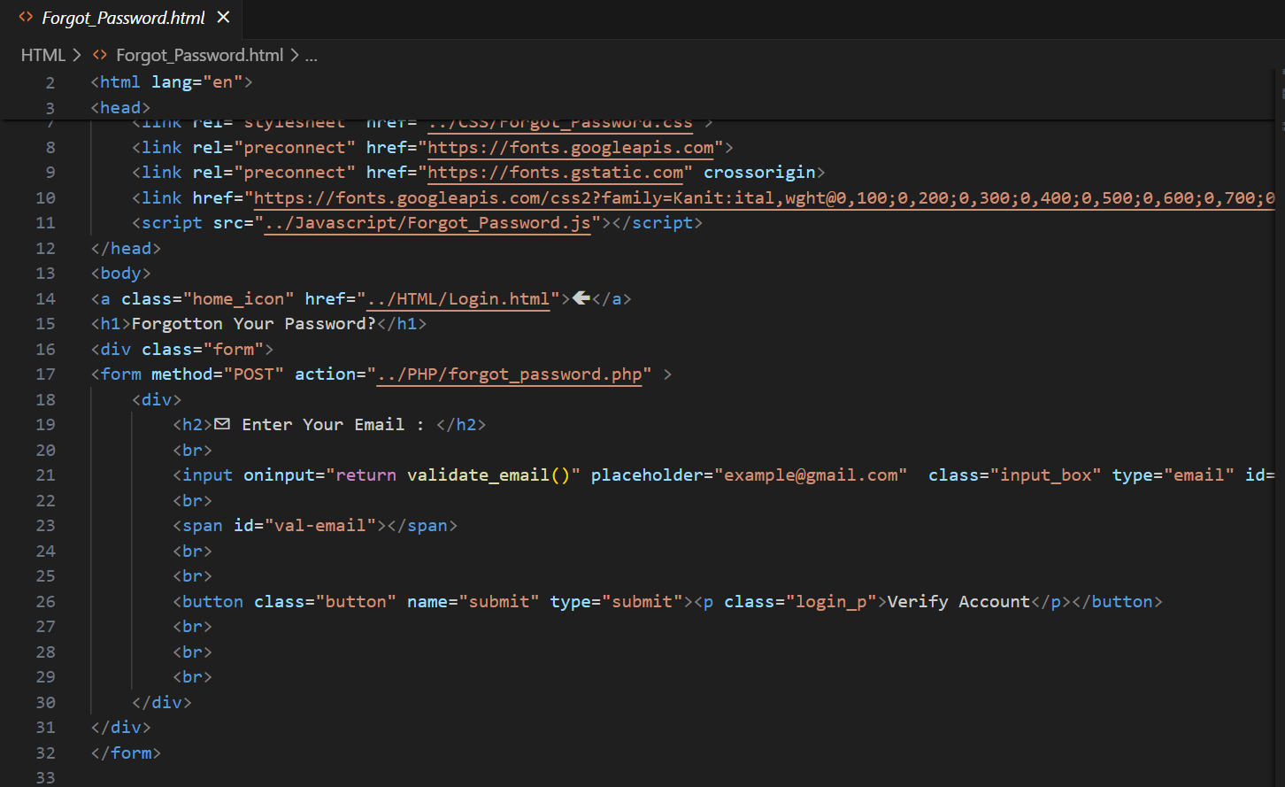

Figure12.3.1

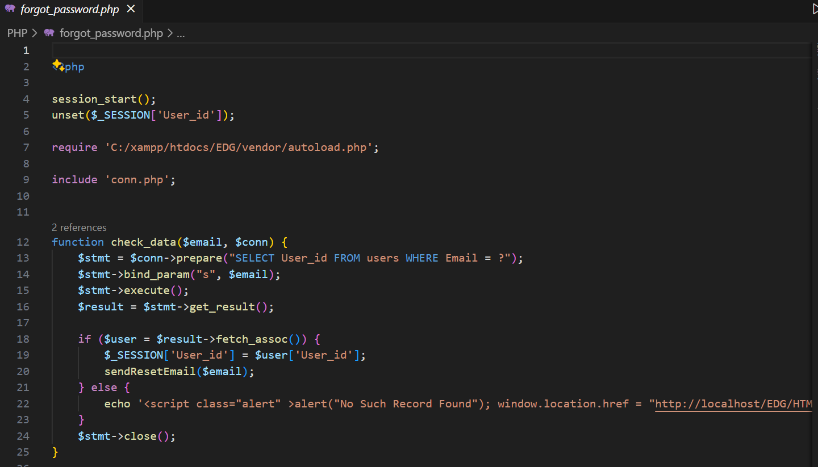

Figure12.3.2

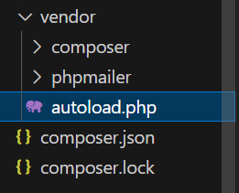

Figure12.3.3

This vendor folder is imported to run the phpmailer function. Phpmailer is a code library that allows users to send emails using PHP code directly to other users. (GeeksforGeeks, 2023) In this project, this function is used to send an email to verify the user’s Gmail account in terms of resetting passwords. This ensures that the password can only be reset by the user who owns the registered Gmail account. The file used to implement this functionality is shown above in Figure 12.3.3.

Example of implementation of the PHP code is shown in Figure 12.3.2.

## 12.4 Reset Password Function

After the verification using the method above, the reset password page is only then accessible for users to enter. The customized page below in Figure 11.4. is sent in a Gmail message as a link to access to.

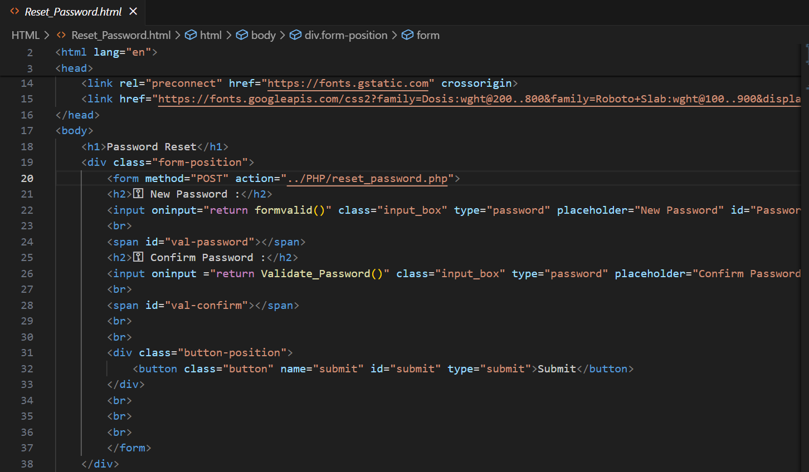

Figure12.4.1

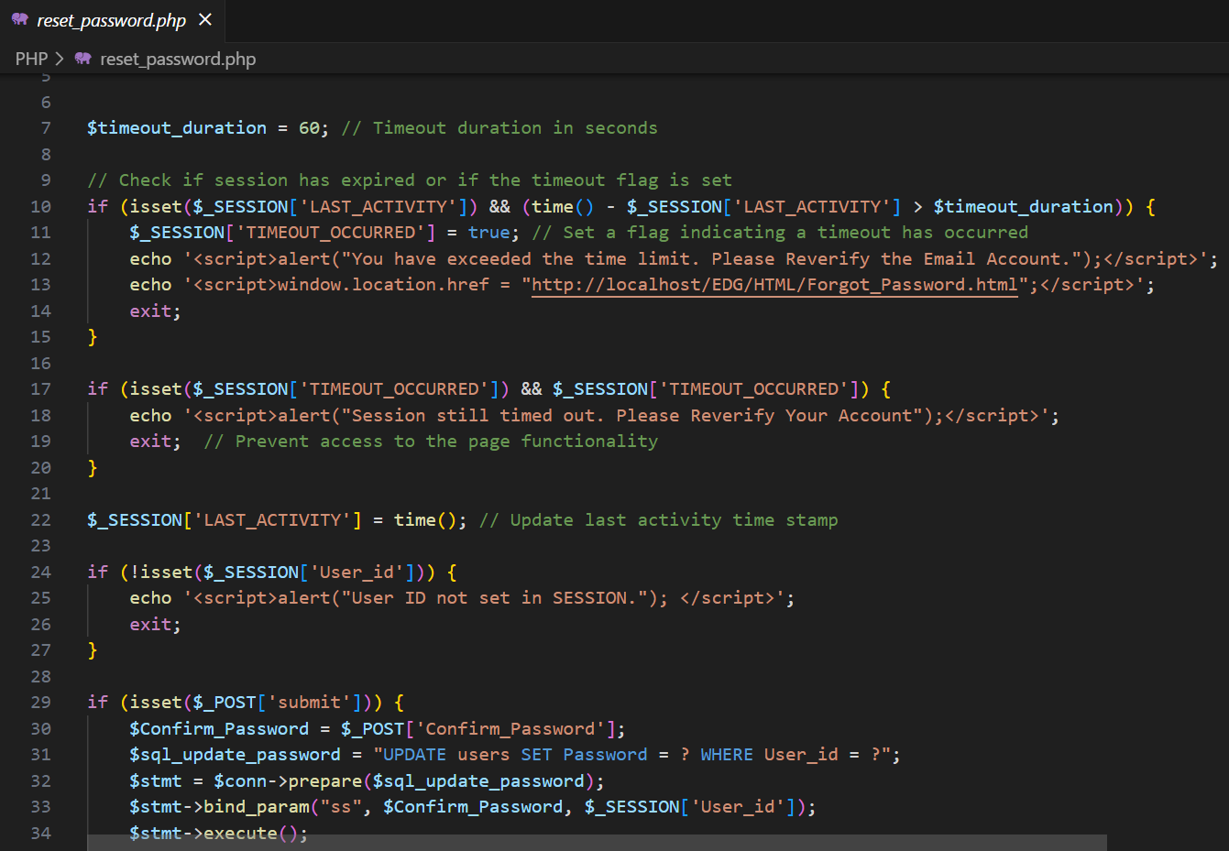

Figure12.4.2

In the linked PHP file Figure12.4.2, a time out will start with a duration of 60 seconds for the user to reset their password using the given link. If the time exceeds the given duration, an alert will notify the user, and the page will no longer be accessible.

# 12.0 Conclusion

To ensure the functionality and usability of the Educational Goat (EDG) platform, several realistic assumptions were made during development. Despite these efforts, the system still has limitations that need to be enhanced in the future.

## 12.1 Assumptions

Users are expected to actively interact with the EDG platform and provide the necessary information to ensure continuous improvement of the system. In order for users to be able to use the platform effectively, they also have the necessary equipment at their disposal, such as suitable devices and a reliable internet connection. In addition, we believe that the design changes will help users with colour vision deficiency (tritanopia and protanopia) to navigate the site without much difficulty. Another assumption is that users trust the platform with their private information and that the data protections in use are sufficient to protect users' information. Finally, it is assumed that the target group finds the learning materials sufficient and useful, and that they do not need to modify them much to improve learning outcomes.

## 12.2 Limitations

Currently, the platform offers only two-colour modes (tritanopia and protanopia), which may not be sufficient for users with other types of colour blindness. Even when user feedback is taken into account, due to the iterative nature of the process, changes may not be implemented quickly enough to address pressing user issues. In addition, it is possible that the platform is not fully optimized for all screen sizes and devices, which may affect the performance of some devices altogether. As the user base expands, scalability issues can arise, causing problems with server capacity, database management, and overall system performance. Finally, some features are not fully completed, which can affect customer satisfaction. Examples of these features include extensive customization options and detailed analysis.

## 12.3 Enhancements

To improve accessibility to a wider user base, more colour mode would be added to the EDG platform to accommodate a wider spectrum of colour vision disorders. Improving the system's ability to collect and process user feedback in real time allows for faster changes and improvements. To ensure a consistent user experience across all platforms, the platform should be more compatible for more devices and screen sizes. System performance can be increased, and a wider user base can be supported by improving database management procedures and server infrastructure. Users are more engaged when new features are introduced, such as advanced configuration options, deep analytics to track user progress, and interactive aspects. Finally, adding accessibility tools increases the inclusiveness of the platform. These features include voice commands, screen reader compatibility and keyboard navigation.

# 13.0 References

Ayers, R. (2023, November 2). *Developing eLearning Platforms For Adults With Special Needs*. E Learning Industry. https://elearningindustry.com/developing-elearning-platforms-for-adults-with-special-needs

‌ Kumar Pal, S. (2018, May 28). *Software Engineering | Spiral Model*. GeeksforGeeks. https://www.geeksforgeeks.org/software-engineering-spiral-model/

‌ National Eye Institute. (2023, August 7). *Types of Color Vision Deficiency | National Eye Institute*. Www.nei.nih.gov. https://www.nei.nih.gov/learn-about-eye-health/eye-conditions-and-diseases/color-blindness/types-color-vision-deficiency

Digital, E. (2021, October 17). How to Make Your Website Color-Blind Accessible. Equalize Digital. https://equalizedigital.com/website-accessibility-color-blind/

Colour Blind Awareness. (2022). *Types of colour blindness*. Colour Blind Awareness.

‌ Pearson, L. (2017, August 14). *The Four Levels of Software Testing | Segue Technologies*. Segue Technologies. https://www.seguetech.com/the-four-levels-of-software-testing/

# 14.0 Appendix

## 14.1 Project Progress

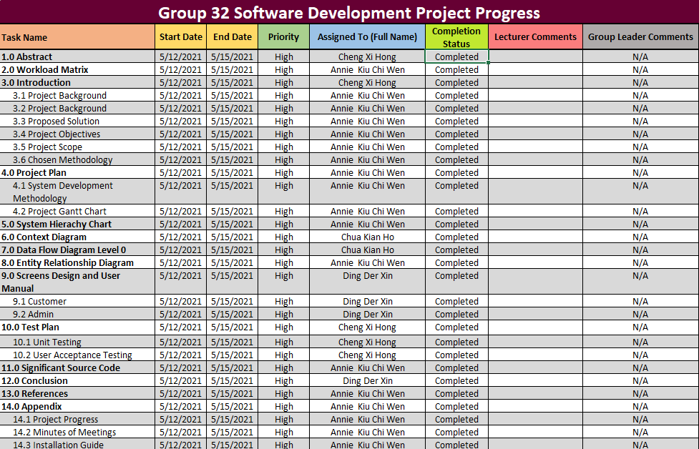

## 14.2 Minutes of Meeting

### 14.2.1 Meeting 1

|  |  |
| --- | --- |
| **Meeting attended by:**  **Annie Kiu Chi Wen (Chaired by)**  **Ding Der-Xin**  **Chua Kian Ho**  **Cheng Xi Hong** | 1. **Proposal workload distribution.** 2. **Website title.** 3. **Chosen topic.** 4. **Documentation framework.** |
| **Absent from meeting:** | **none** |
| **Date, Time & Venue:** | **10/02/2024, 4:30pm, campus** |
| **Agenda(s): discuss website flow.** | |
| **Notes: introduction must not clash with project plan; conclusion must include project motivation** | |
| **Action Item(s) & Deadlines:**   1. **Final proposal before week 6.** | |
| **Proposed Date & Time for Next Meeting: 14/3/2024** | |

### 14.2.2 Meeting 2

|  |  |
| --- | --- |
| **Meeting attended by:**  **Annie Kiu Chi Wen (Chaired by)**  **Ding Der-Xin**  **Chua Kian Ho**  **Cheng Xi Hong** | 1. **Website specification** 2. **User segmentation** 3. **System hierarchy chart** 4. **E learning topic** |
| **Absent from meeting:** | **none** |
| **Date, Time & Venue:** | **16/03/2024, 10:30pm, online meeting** |
| **Agenda(s): organize project plan** | |
| **Notes: flow of how website function starting from basic interface where all users can use to modes specifically for partial color blind. Topic chosen is math questions starting from different categories.** | |
| **Action Item(s) & Deadlines:**   1. **Final proposal before week 6.** | |
| **Proposed Date & Time for Next Meeting: 14/3/2024** | |

### 14.2.3 Meeting 3

|  |  |
| --- | --- |
| **Meeting attended by:**  **Annie Kiu Chi Wen (Chaired by)**  **Ding Der-Xin**  **Chua Kian Ho**  **Cheng Xi Hong** | 1. **Project Flow** 2. **Interface Design** 3. **System Functions** 4. **User login flow** 5. **Admin login flow** |
| **Absent from meeting:** | **none** |
| **Date, Time & Venue:** | **26/3/2024, 11:00 pm, online meeting** |
| **Agenda(s): project flow specification** | |
| **Notes: introduction and conclusion deadline, interface color choice and designs** | |
| **Action Item(s) & Deadlines:**   1. **Introduction and conclusion deadline on 31/3/2024** | |
| **Proposed Date & Time for Next Meeting: 4/4/2024** | |

### 14.2.4 Meeting 4

|  |  |
| --- | --- |
| **Meeting attended by:**  **Annie Kiu Chi Wen (Chaired by)**  **Ding Der-Xin**  **Chua Kian Ho**  **Cheng Xi Hong** | 1. **Interface design** 2. **Admin functions** 3. **Database bugs** 4. **Data flow diagram level 0** |
| **Absent from meeting:** | **none** |
| **Date, Time & Venue:** | **4/4/2024, 11:00 pm, online meeting** |
| **Agenda(s): coding collaboration problems** | |
| **Notes: final database structure** | |
| **Action Item(s) & Deadlines:**   * 1. **Finalize database structure** | |
| **Proposed Date & Time for Next Meeting: 15/4/2024** | |

### 14.2.5 Meeting 5

|  |  |
| --- | --- |
| **Meeting attended by:**  **Annie Kiu Chi Wen (Chaired by)**  **Ding Der-Xin**  **Chua Kian Ho**  **Cheng Xi Hong** | 1. **Context Diagram** 2. **Database bugs** 3. **Data flow diagram level 0** 4. **Documentation report** |
| **Absent from meeting:** | **none** |
| **Date, Time & Venue:** | **15/4/2024, 11:00 pm, online meeting** |
| **Agenda(s): check If code compiling well together** | |
| **Notes: documentation workload distribution** | |
| **Action Item(s) & Deadlines:**   * 1. **Code check** | |
| **Proposed Date & Time for Next Meeting: 28/4/2024** | |

## 14.3 Installation Guide

Step-by-Step Installation Guide for Educational Goat (EDG) Platform

In File Explorer,

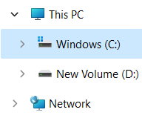

Go to C drive,

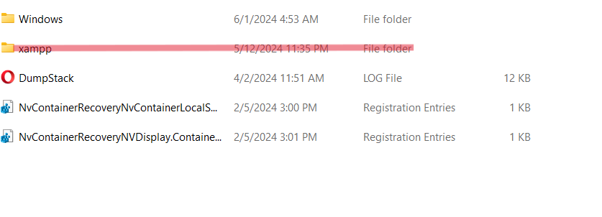

Find the XAMPP folder, it could be in "C:\Program Files" or “C:\Program Files (x86)" depending on where u saved the folder.

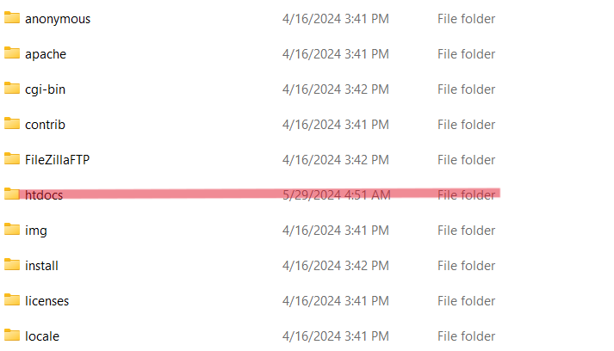

After locating it, open the htdocs folder in xampp folder.

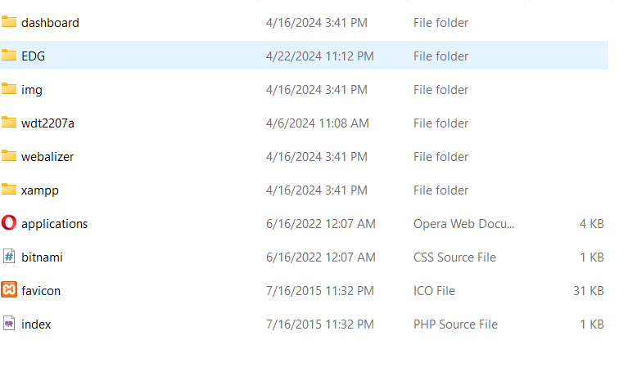

Drag and drop the downloaded EDG folder into htdocs. If the EDG folder is in zipped file format, be ensured that it is unzipped before placing it into htdocs.

Then, open the XAMPP control panel.

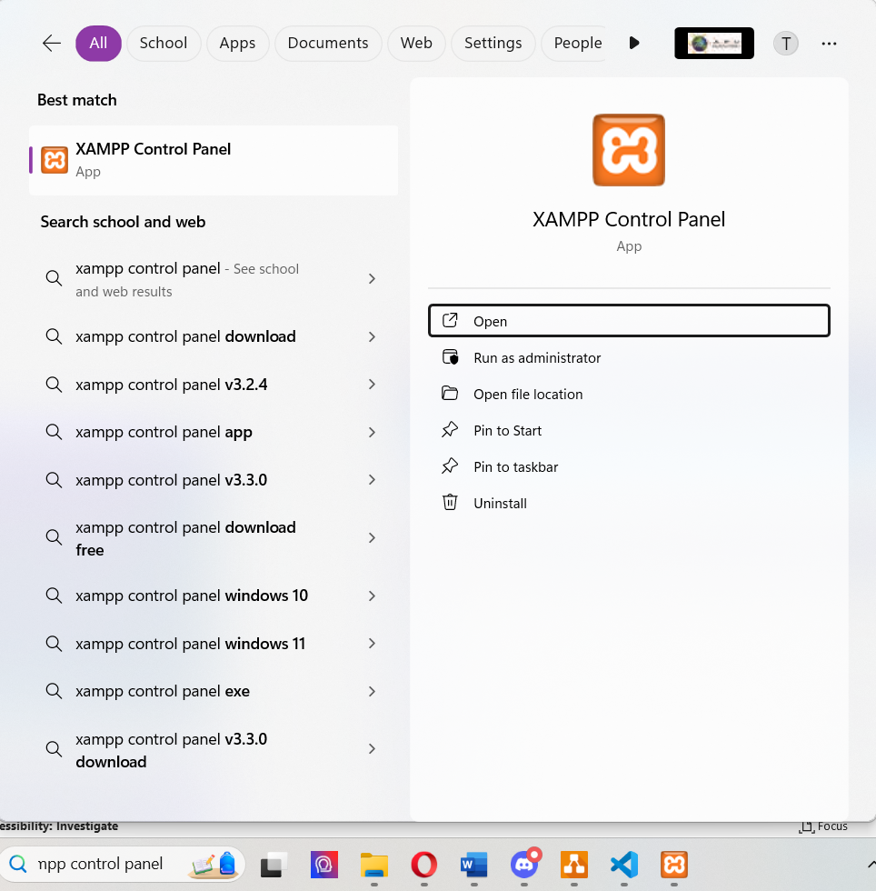

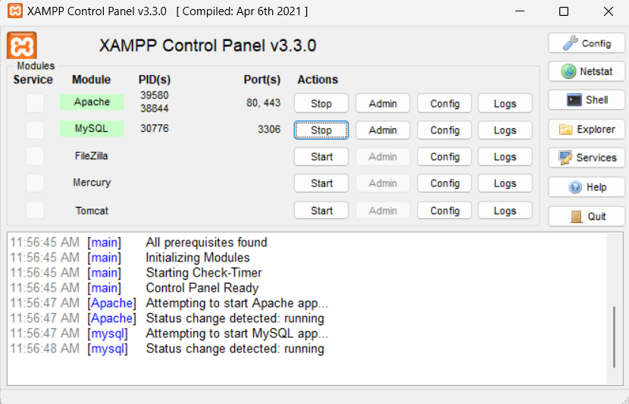

Ensure to start Apache and MySQL in the XAMPP Control Panel.

Moving on, go to localhost phpMyAdmin,

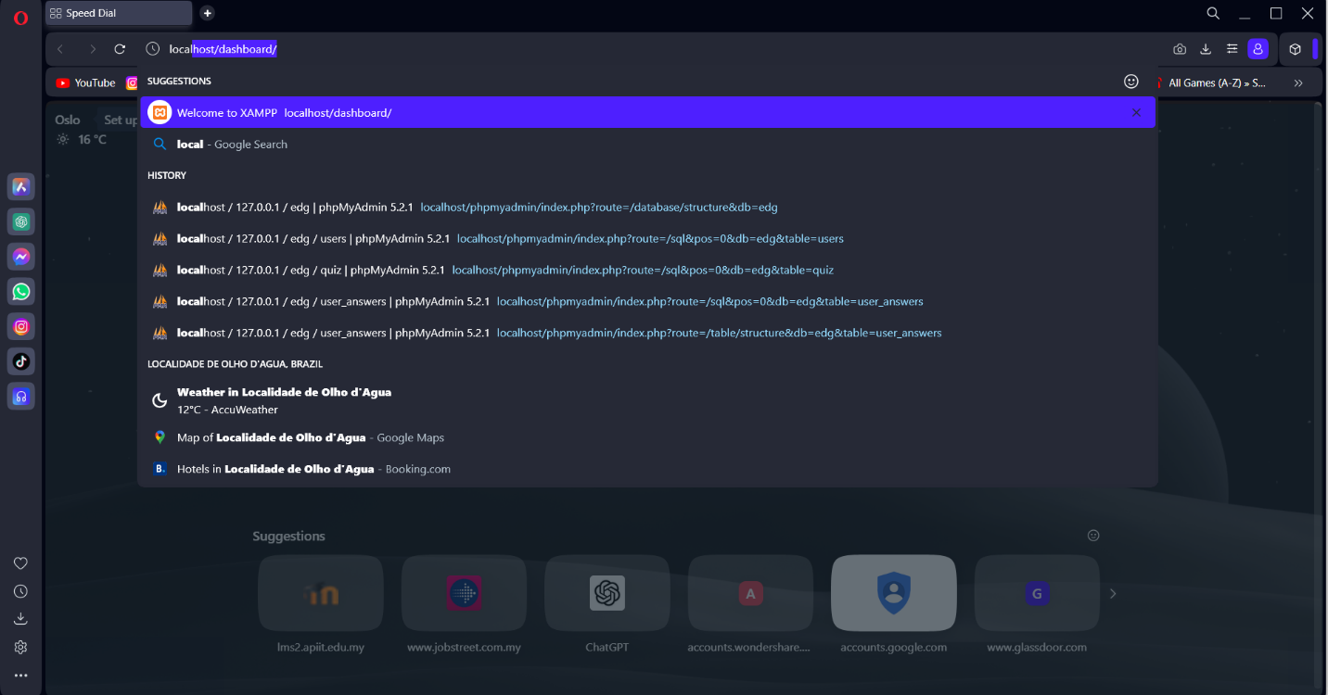

This can be done in any web browser preferred.

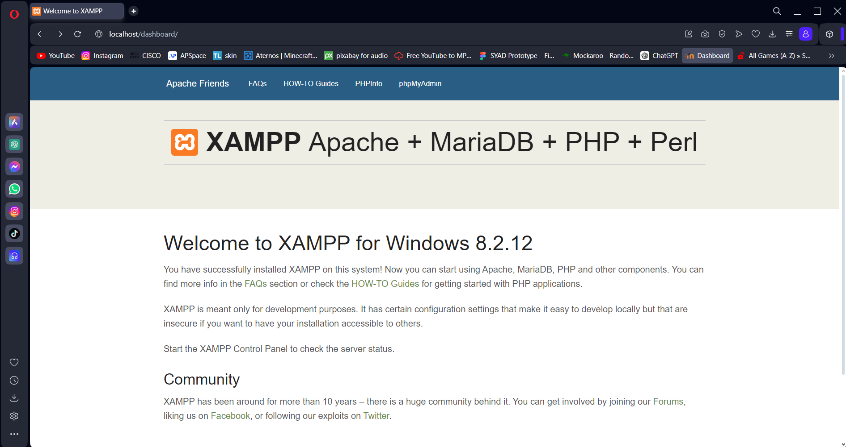

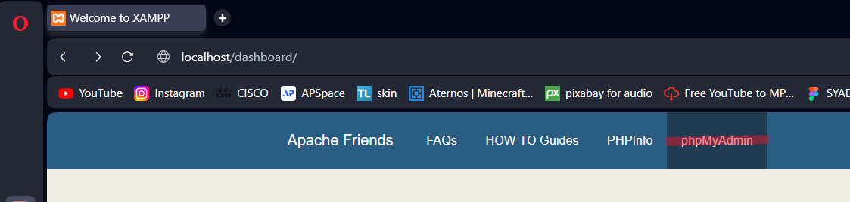

Click phpMyAdmin,

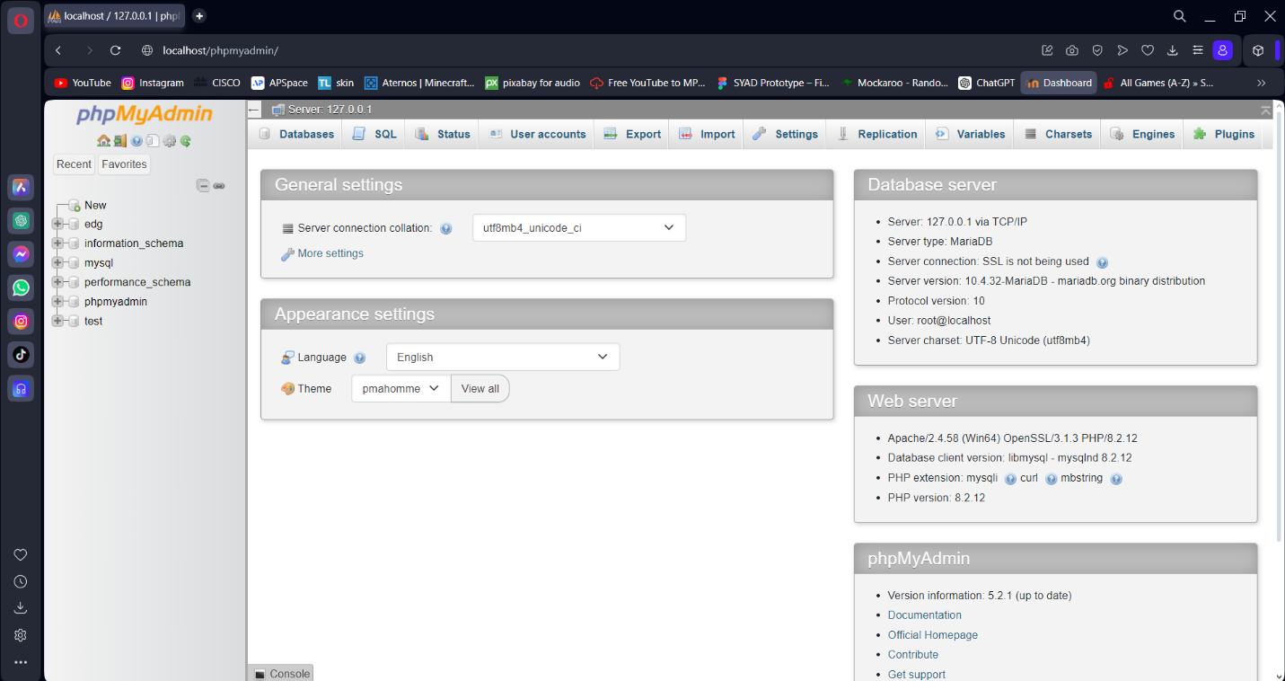

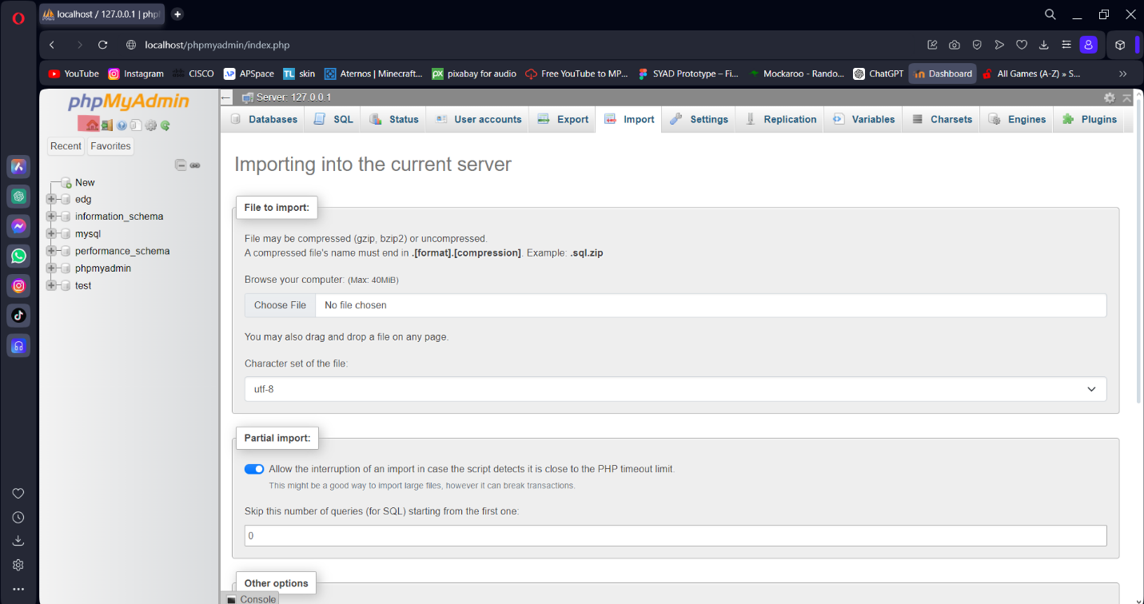

Click the house icon on the top left corner of phpMyAdmin.

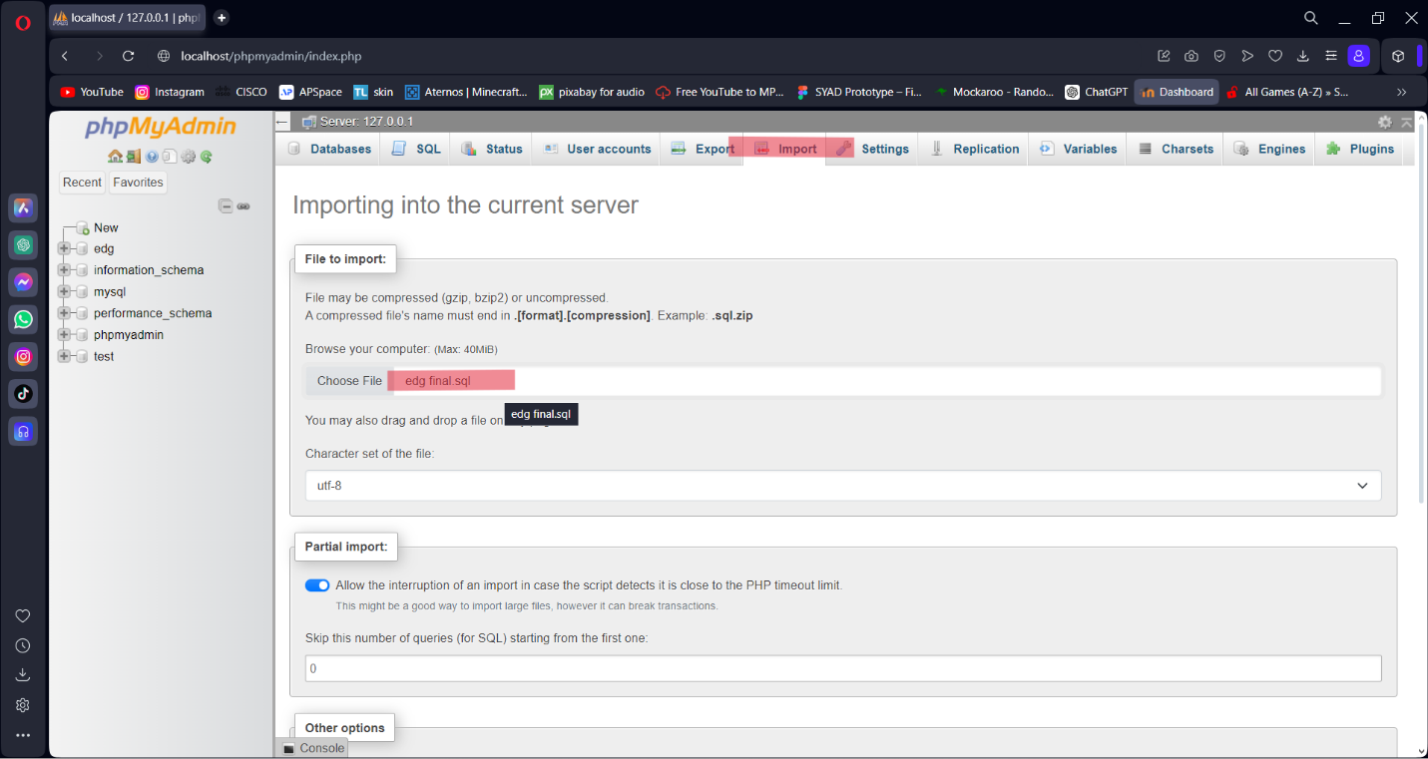

Click import and insert the SQL file after downloading it together with the EDG folder given.

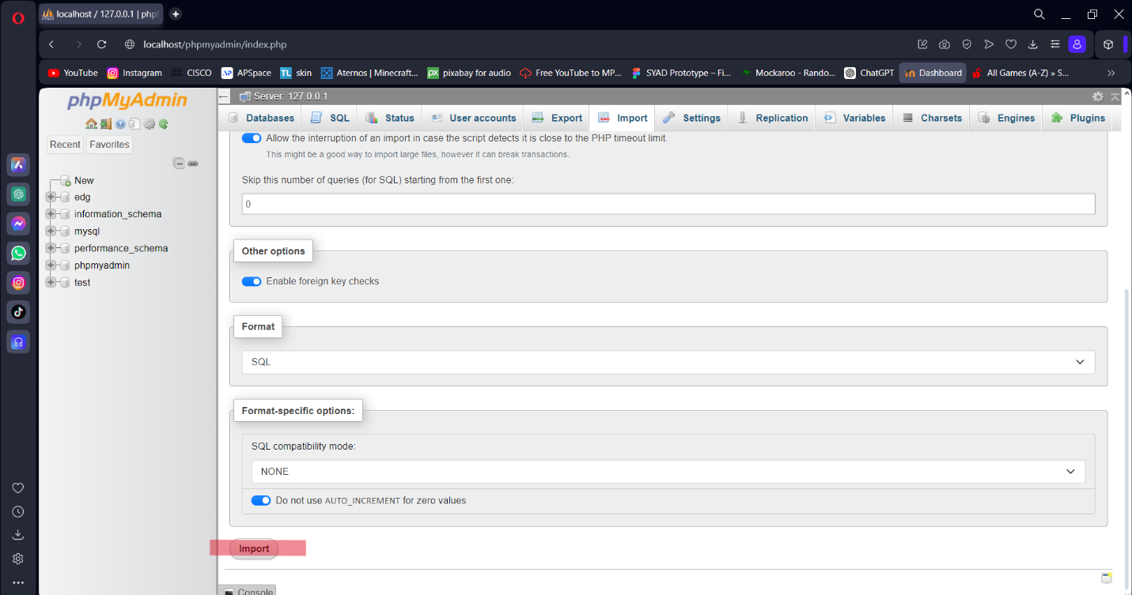

Click import at the very bottom of this section to finish the import process. This step creates the database needed to run the website.

Final step,

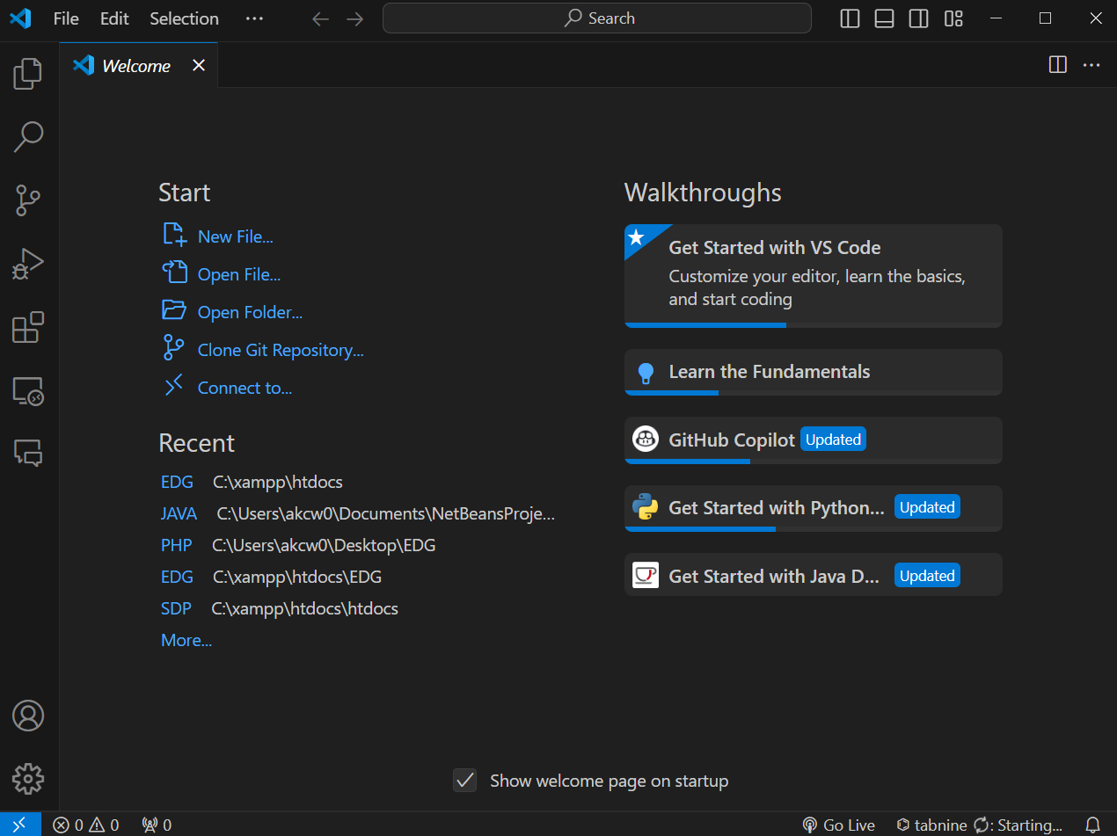

Open visual studio code, open EDG folder that is now stored in XAMPP, htdocs.

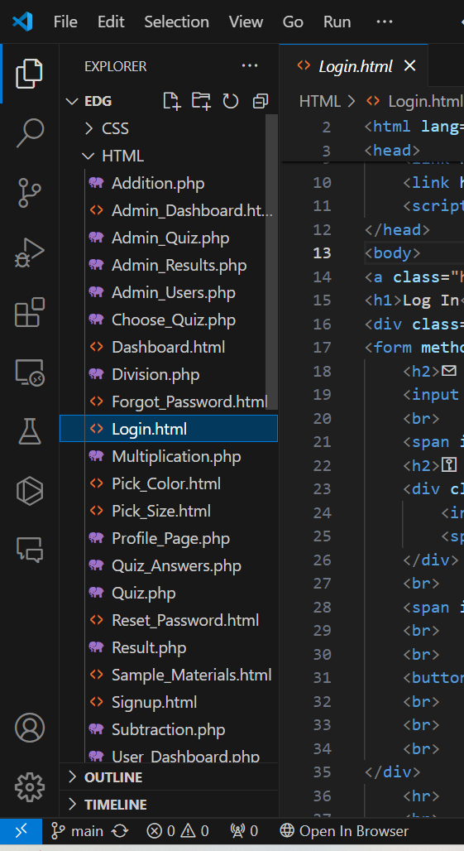

Locate Login.html in HTML Folder.

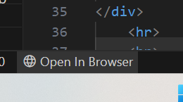

Then click Open in Browser.

The Code should now run smoothly.